RIVANNA RIVER STEWARD REPORT
River Steward Names: Justin Altice and Dan Triman Date: 5-13-15
Starting Location and Time: Crofton (3:30 PM)
Ending Location and Time: Palmyra (6:30 PM)
Weather: Overcast Recent Precipitation: Not much rain recently
Water Flow: Fairly Slow Water Color: Somewhat Brownish Water Odor: None
Water Temp. : 20 deg C Air Temp. : 70 deg F
DO: 5 ppm PH: 8 Turbidity: 40 JTU
USGS Water Gauge Reading: Earlysville 1.67 ft, Palmyra 3.18 ft.
Physical Location Characteristics: River right along beach just before Palmyra
Location Tested: 37°51'37.0"N 78°16'01.8"W
---------------------------------------------------------------------------------
Land Use:
Mostly open space and wooded areas, with some farms and residential.

Wildlife Sightings and Plant Life:
Turtles, fish, geese, cormorants, osprey, bald eagle (seen by other paddlers), dragonflies, butterflies, and several other smaller birds.

People Interactions:
We saw a couple of people out on the water fishing, a couple kayaking, and a couple swimming in the water.

Litter and Pollution:
Only a few scattered pieces of trash were found (bottles and cans mostly). There were some larger items found like a chair, and kids’ toy vehicles.

Overall Summary:
The water level was fairly low but paddling was smooth for the most part. Saw only a few wildlife here and there. Some erosion on the banks was noticed, and a pipe near the Crofton boat ramp (River right) was discharging a significant amount of water (see photo below). We spoke to a couple of other people today out on the River. Water had a brownish color from sediment.

Actions Needed – level of priority (1 highest/5 lowest):
Determine if any action needed for pipe discharging water near Crofton (3)

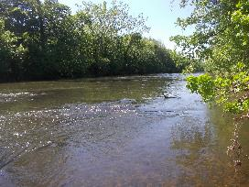
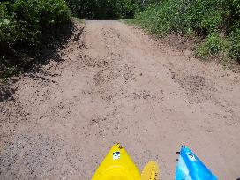
Figure 1: Crofton Boat Launch Ramp covered in sediment Figure 2: View up river from Crofton Boat Launch
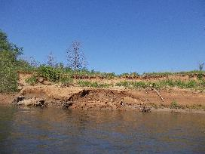
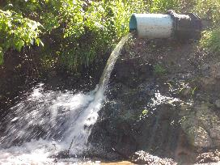
Figure 3: Pipe discharging a lot of water near Crofton Figure 4: Example of eroded river bank
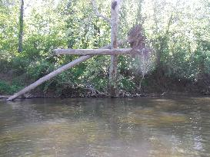

Figure 5: Uprooted tree suspended in another tree

