RIVANNA RIVER STEWARD REPORT
River Stewards: Dan Triman Date: 5-29-16
Starting Location and Time: Free Bridge (11:00 AM)
Ending Location and Time: Milton (2:30 PM)
Weather: Cloudy, Drizzly Recent Precipitation: A few heavy rains past week
USGS Gauges: Earlysville 2.00 ft (110 ft³ / sec), Palmyra 3.70 ft (720 ft³ / sec),
Water Color: Mostly Clear Water Odor: None Air Temp. : 75 deg F
DO: 5 ppm PH: 8 Turbidity: 10 JTU Water Temp. : 21 deg C
Water Testing Location: Milton Bridge River Left (38°00.4’N 78°24.0’W)
---------------------------------------------------------------------------------
Land Use:
Mix of residential, park, and commercial properties. Mostly wooded once you get past Woolen Mills area.

Wildlife Sightings and Plant Life:
Turtles, Crows, Ducks, Fish, Geese, Small Birds. There is still an eagle’s nest up on the power line tower near Milton. With all the recent rain and warmer temperatures all the vegetation is very robust along the River.

People Interactions:
Memorial Day weekend brought out lots of people today. At least 10 people seen kayaking or fishing in the River, lots of people swimming and on the beaches, and more cars at Milton Boat Ramp then ever seen before.

Litter and Pollution:
Mostly small litter such as bottles & cans found. Removed ½ of a large trash bag worth of items from the River. Also found a basketball, and a children’s playground slide. 2 Tires were seen during the paddle as well.

Overall Summary:
Water levels are still up slightly. We attempted to locate 2 kayaks reported lost / abandoned recently. One was ¼ mile before Riverview Park, and the other at Milton. Neither kayak was found during the paddle. Glad to see so many people enjoying the River. Milton Landing sign is no longer at steps.

Actions Needed – level of priority (1 highest/5 lowest):
2 – Fix Riverview steps; 4 – Remove tires and children’s slide from River.

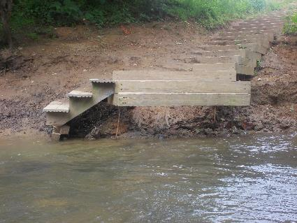
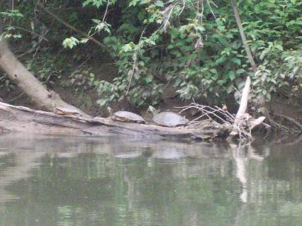
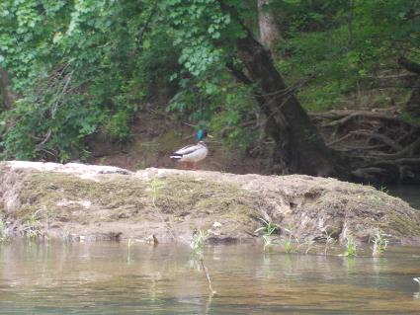
Figure 1: Turtles on a log Figure 2: Riverview steps the City is going to work on soon
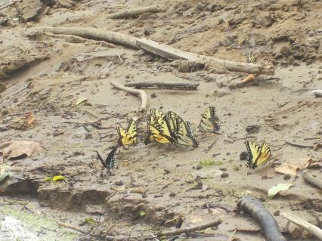
Figure 3: Butterflies on a river bank Figure 4: Duck on a rock
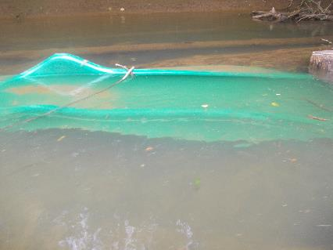
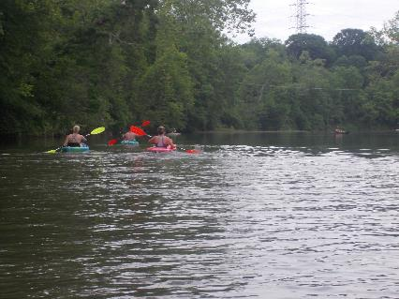
Figure 5: Some of the other kayaks out today Figure 6: Children’s playground slide in the water

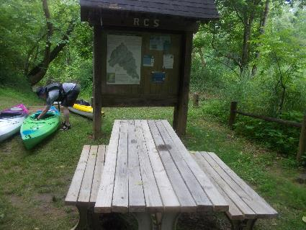
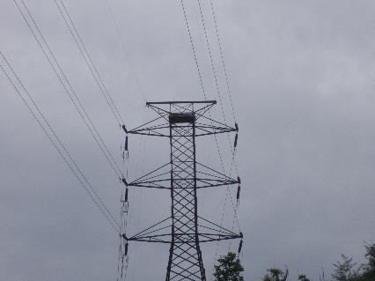
Figure 7: Eagles nest on power line tower Figure 8: RCA Kiosk and table are still in good shape at Milton
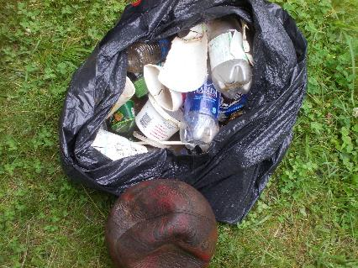
Figure 9: Some of the trash removed during the paddle

