RIVANNA RIVER STEWARD REPORT
River Stewards: Dan Triman Date: 06-10-16
Starting Location and Time: Ragged Mountain Reservoir (7:30 AM)
Ending Location and Time: Ragged Mountain Reservoir (9:30 AM)
Weather: Sunny w/ some clouds Recent Precipitation: No rain past few days
USGS Gauges: Earlysville 1.80 ft (80 ft² / sec), Palmyra 3.50 ft (500 ft² / sec),
Water Color: Blue Water Odor: None Air Temp. : 70 deg F
DO: 5 ppm PH: 8 Turbidity: 10 JTU Water Temp. : 24 deg C
Water Testing Location: Just Below Parking Area @ East Side of Reservoir
---------------------------------------------------------------------------------
Land Use:
Park land around reservoir with a wooded buffer.

Wildlife Sightings and Plant Life:
Turtles, Ducks, Geese, Crows, Small Birds, Small Fish, 2 baby deer, and 1 large snapping turtle. 1 dead Catfish found floating in the water. Also saw a hawk catching a baby rabbit on the drive in on Reservoir Rd. Good amount of vegetation growing out of the water, and mix of trees, grasses, and other plants along the banks.

People Interactions:
Saw 1 Kayaker about to get into the Reservoir when I was leaving, and 2 fishermen in a boat on the Southwest corner of the Reservoir. Several people were seen using the trails around the Reservoir.

Litter and Pollution:
Removed about ½ a large trash bag of bottles, and fishing bait boxes.

Overall Summary:
Nice morning to be out for a paddle, as the weather was cool and not many people around. The Reservoir was in good shape overall. Didn’t see any signs of algae, but there was some film on the water in some places. Found 1 dead catfish floating in the water and a lot of trash in one particular stagnant water spot just to the north of the parking area. Lots of wildlife seen and a good variety of plant life.

Actions Needed – level of priority (1 highest/5 lowest):
2 – Continue to monitor the Reservoir for Algae Blooms.
2 – Look into why dead fish are being found in the Reservoirs

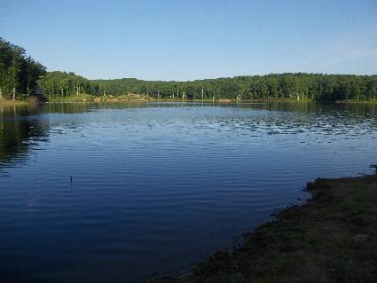
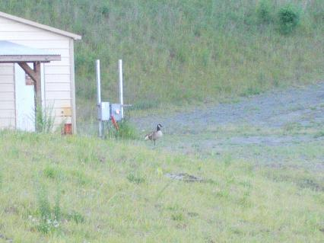
Figure 1: Goose by the shed Figure 2: View of the Reservoir from the parking area

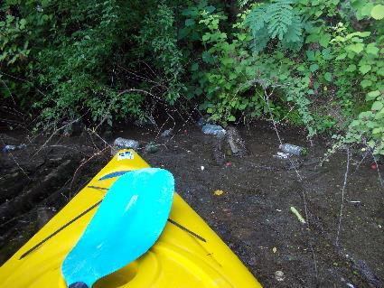
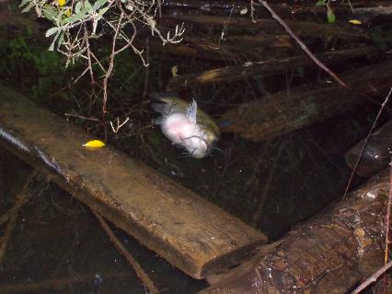
Figure 3: Dead catfish found floating in the water Figure 4: Trash area near the parking lot
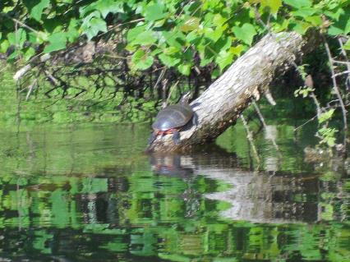
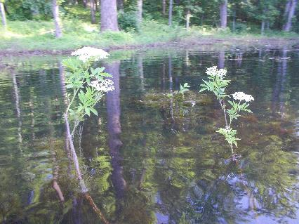
Figure 5: Some of the vegetation growing in the water Figure 6: Turtle on a log

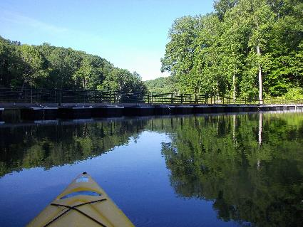
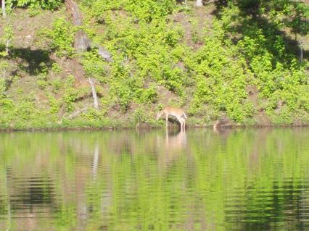
Figure 7: One of the baby deer seen today Figure 8: View at the pedestrian bridge

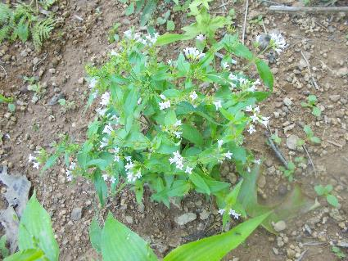
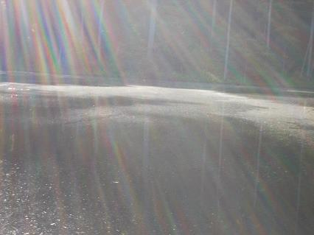
Figure 9: Film on the top of the water Figure 10: Flowers along the bank
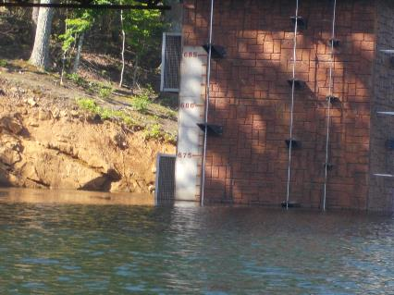
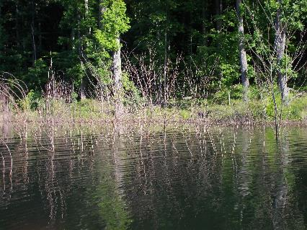
Figure 11: Most common plants growing in the water Figure 12: View of the building showing water levels

