RIVANNA RIVER STEWARD REPORT
River Steward Name(s): Justin Altice Date: 06-13-15
Starting Location and Time: Lewis and Clark Center 11:45 AM
Ending Location and Time: Riverview Park 1:15 PM
Weather: Sunny with a few Clouds Recent Precipitation: Downpour of rain the previous evening
Water Flow: Mild current (river was up) Water Color: Murky
Water Temp. : 75° F Air Temp. : 95° F
DO: 4 ppm PH: 8.0 Turbidity: 60 JTU
USGS Water Gauge Reading: Palmyra 3.4 ft
Physical Location Characteristics: Lewis and Cark Exploratory Center
Land Use:
Residential development with a wooded buffer around the river that contains
the RTF

Wildlife Sightings and Plant Life:
Ducks, Turtles, Heron, Invasive Bamboo Grove (near Darden Towe)

People Interactions:
Provided boats for Streamwatch volunteer appreciation outing; 13 people went out with me. Saw many 5 people in floats (2 fishing), many folks swimming near Darden Towe Park and Riverview Park (25 people), and a few other kayakers (4 people).

Litter and Pollution:
Trip was not focused on a cleanup effort but I still picked up a few cans and Styrofoam cups. Very muddy run-off coming downhill from Darden Towe Park where we put in below the Lewis and Clark Center; this was attributable to heavy downpours the previous evening.

Overall Summary:
Extremely hot and humid day, water temperatures were moderate which provided a welcome reprieve from heat. Many of the Streamwatch volunteers who participated had never boated down the Rivanna river and really enjoyed the experience. Streamwatch had an awards ceremony and picnic at Riverview Park upon our arrival there.

Actions Needed – level of priority (1 highest/5 lowest)
3 – Fix two canoes with broken slats, 3-check hydrology near Lewis and Clark Center to see how severe runoff could be mediated

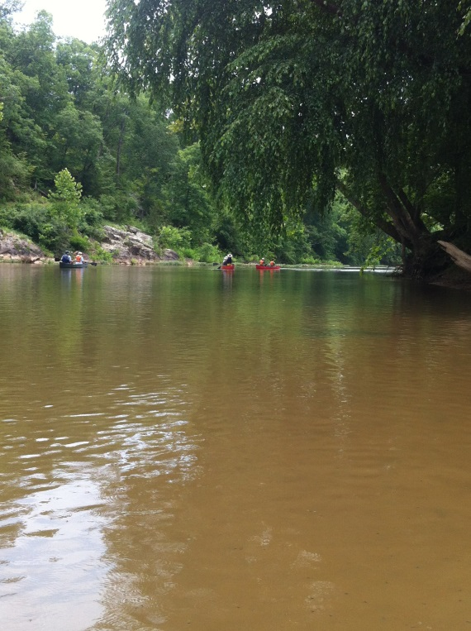
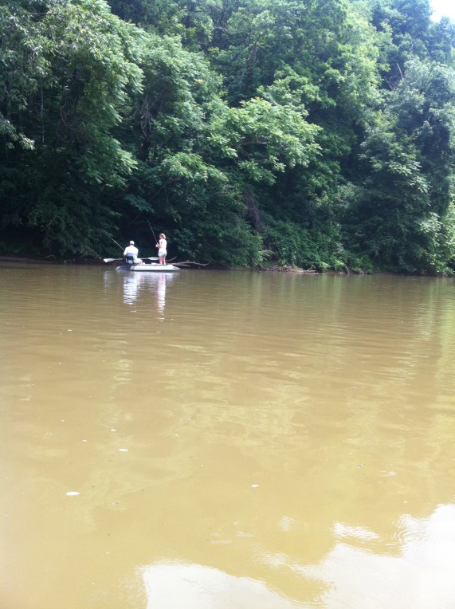
Figure 1: Folks enjoying fishing on the River Figure 2: Canoers on the River

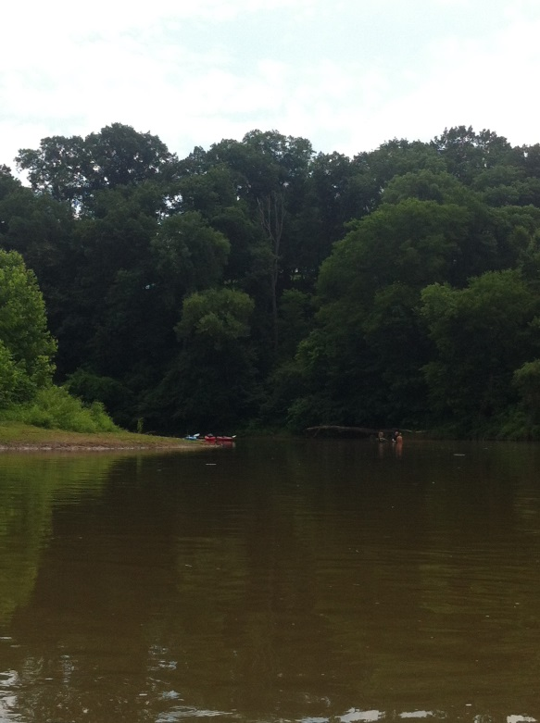
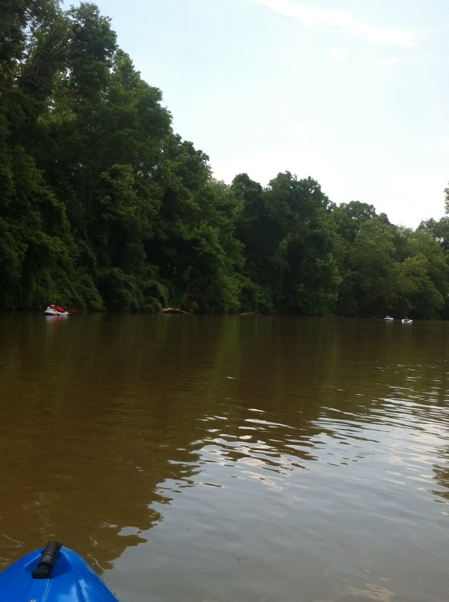

Figure 3: Tubers enjoying the River Figure 4: Folks swimming in the River

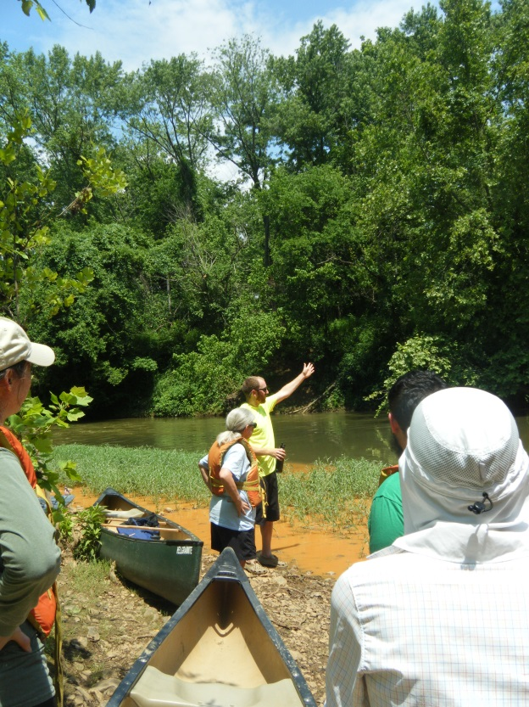
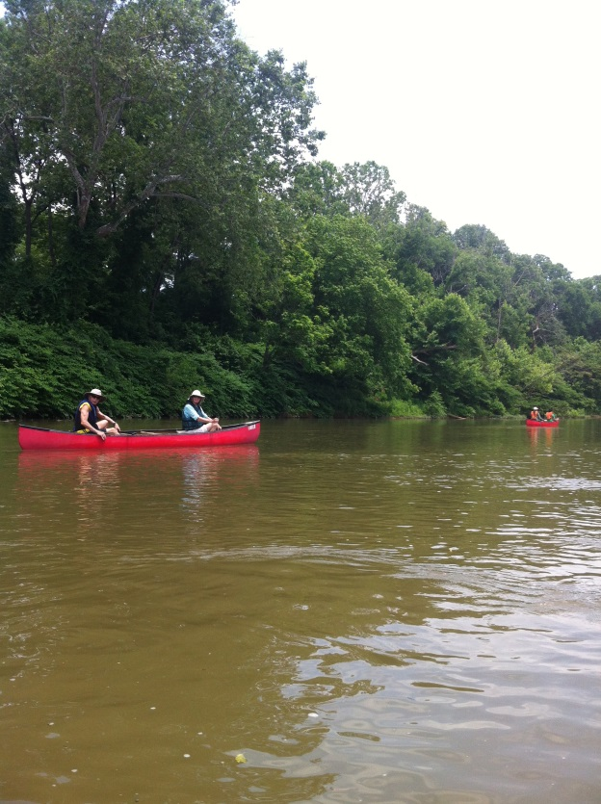
Figure 5: Streamwatch volunteeers in Canoes Figure 6: Preparation talk with Streamwatch

