RIVANNA RIVER STEWARD REPORT
River Stewards: Jessica Dodds and David Smith Date: 6-13-16
Starting Location and Time: Palmyra (8:30 AM)
Ending Location and Time: Private pull out (3:30 PM)
Weather: Sunny Recent Precipitation: Not much rain recently
USGS Gauges: ____ ____ ft (__ ft³ / sec), Palmyra 3.3 ft (370 ft³ / sec),
Water Color: Mostly Clear Water Odor: None Air Temp. : Not measured [NM]
DO: NM PH: NM Turbidity: NM Water Temp. : NM deg C
Water Testing Location: N/A
---------------------------------------------------------------------------------NOTE: This paddle trip was to perform a Streamwatch sample event at Rivanna Mills. Put in at Palmyra and paddled ~11 miles to site. NO riffles were observed so sampling did not take place. Photo-documented conditions, then paddled (15 minutes to private residence takeout). Chatted with landowner re conditions
Land Use:
Mostly tree lined and hard to tell ownership

Wildlife Sightings and Plant Life:
Turtles, Beaver, Green Heron, Hawks, Fish (Gar and others), snake, Geese, Ducks, and smaller birds.

People Interactions:
Did not see anyone on the River. This stretch is normally a 16 mile trek from Palmyra to Columbia.

Litter and Pollution:
Noted many cans and minor debris in the river, and many tires. No trash removal undertaken as this was a sampling event.

Overall Summary:
Water was pretty clear, although base appeared very sandy (note there is no baseline to compare to) Will meet with previous samplers/Rose to discuss alternative sampling locations. No “sample-able” riffles observed.

Actions Needed – level of priority (1 highest/5 lowest):
1 – Follow up with landowner who expressed interest in having his son become involved in stream monitoring.
3 – plan a trash/tire pull at some point – will be a long day and will likely have to travel to the Columbia pull out.

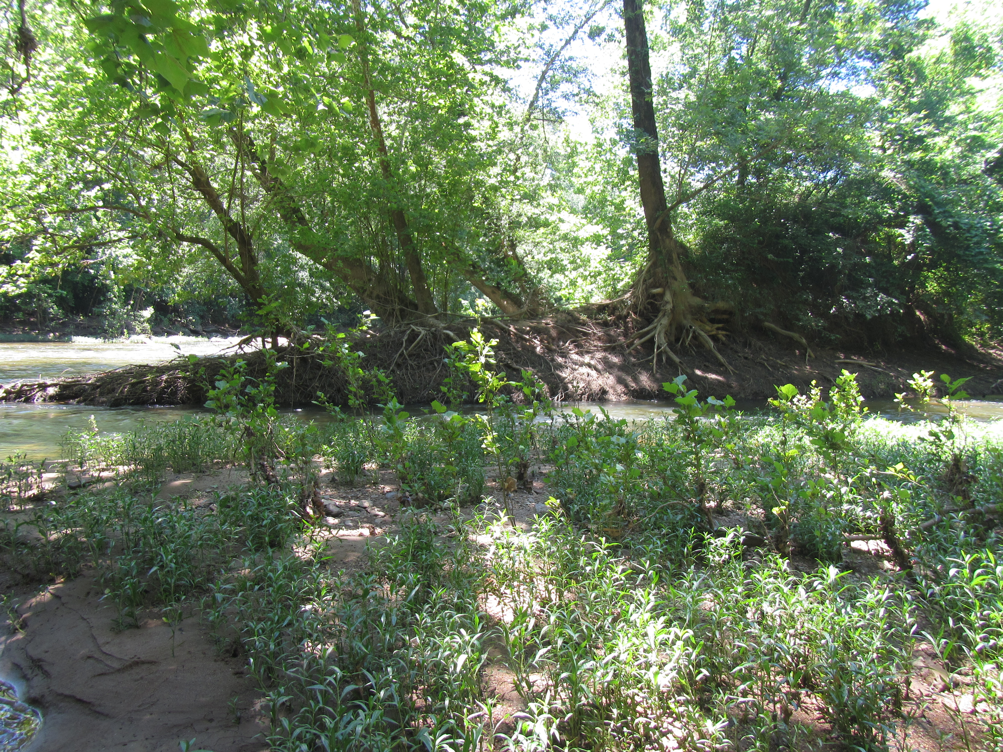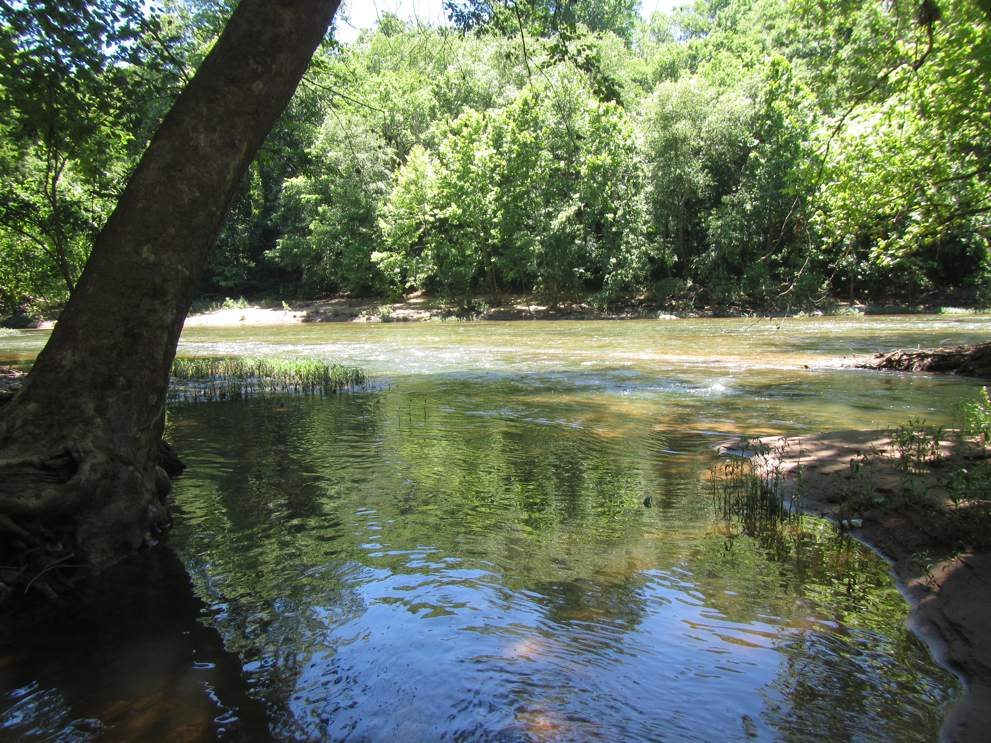
Figure 1. A washed-away bank Figure 2. Upstream looking at the “site”

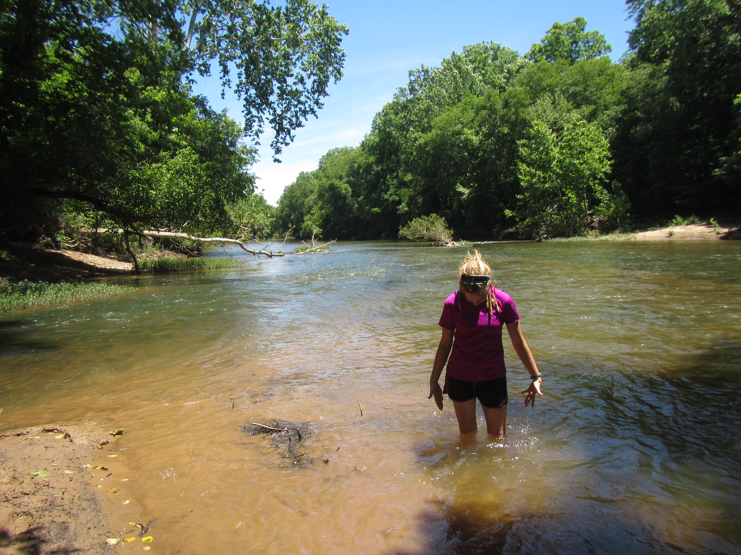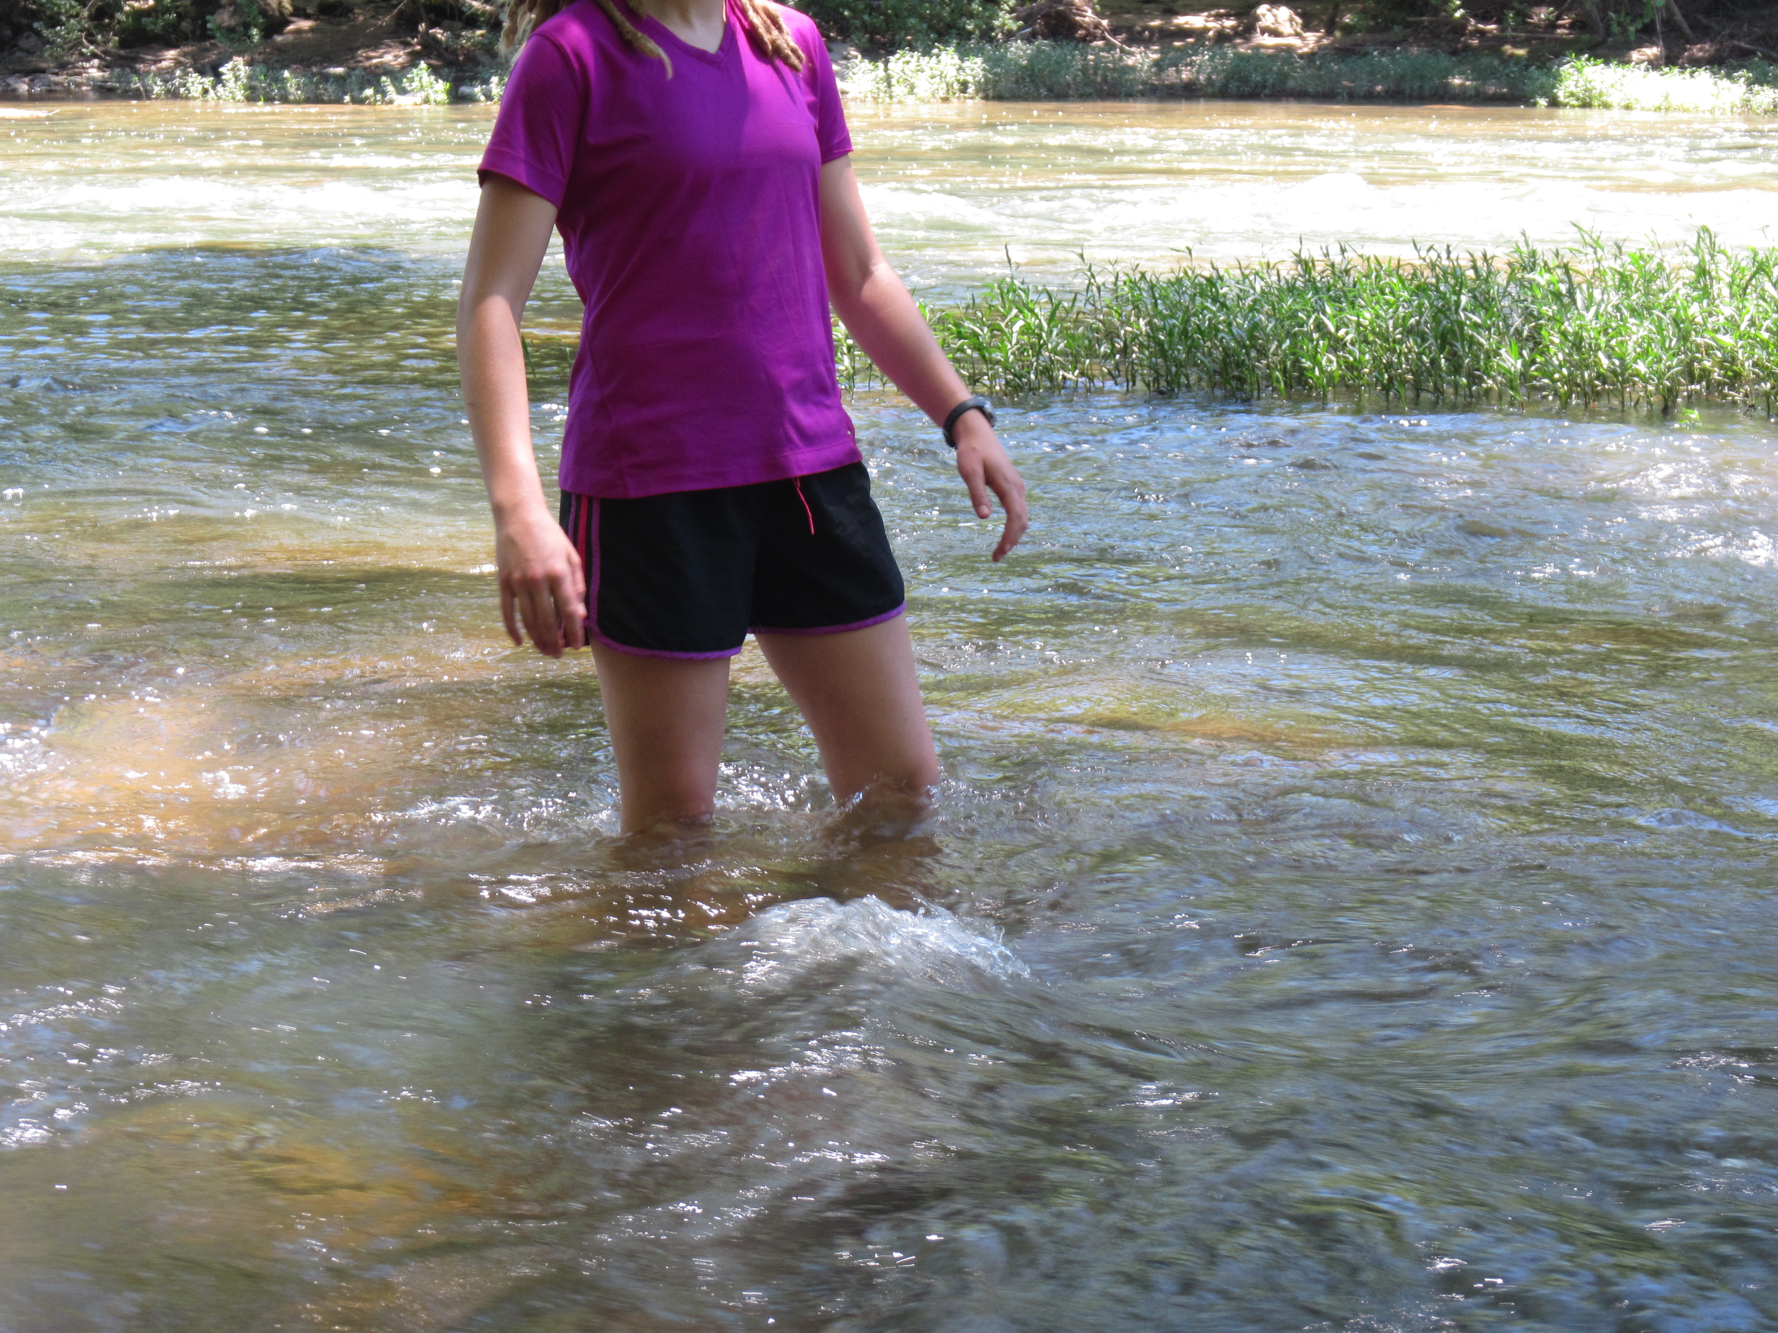
Figures 3 and 4. Standing where the riffles are supposed to be

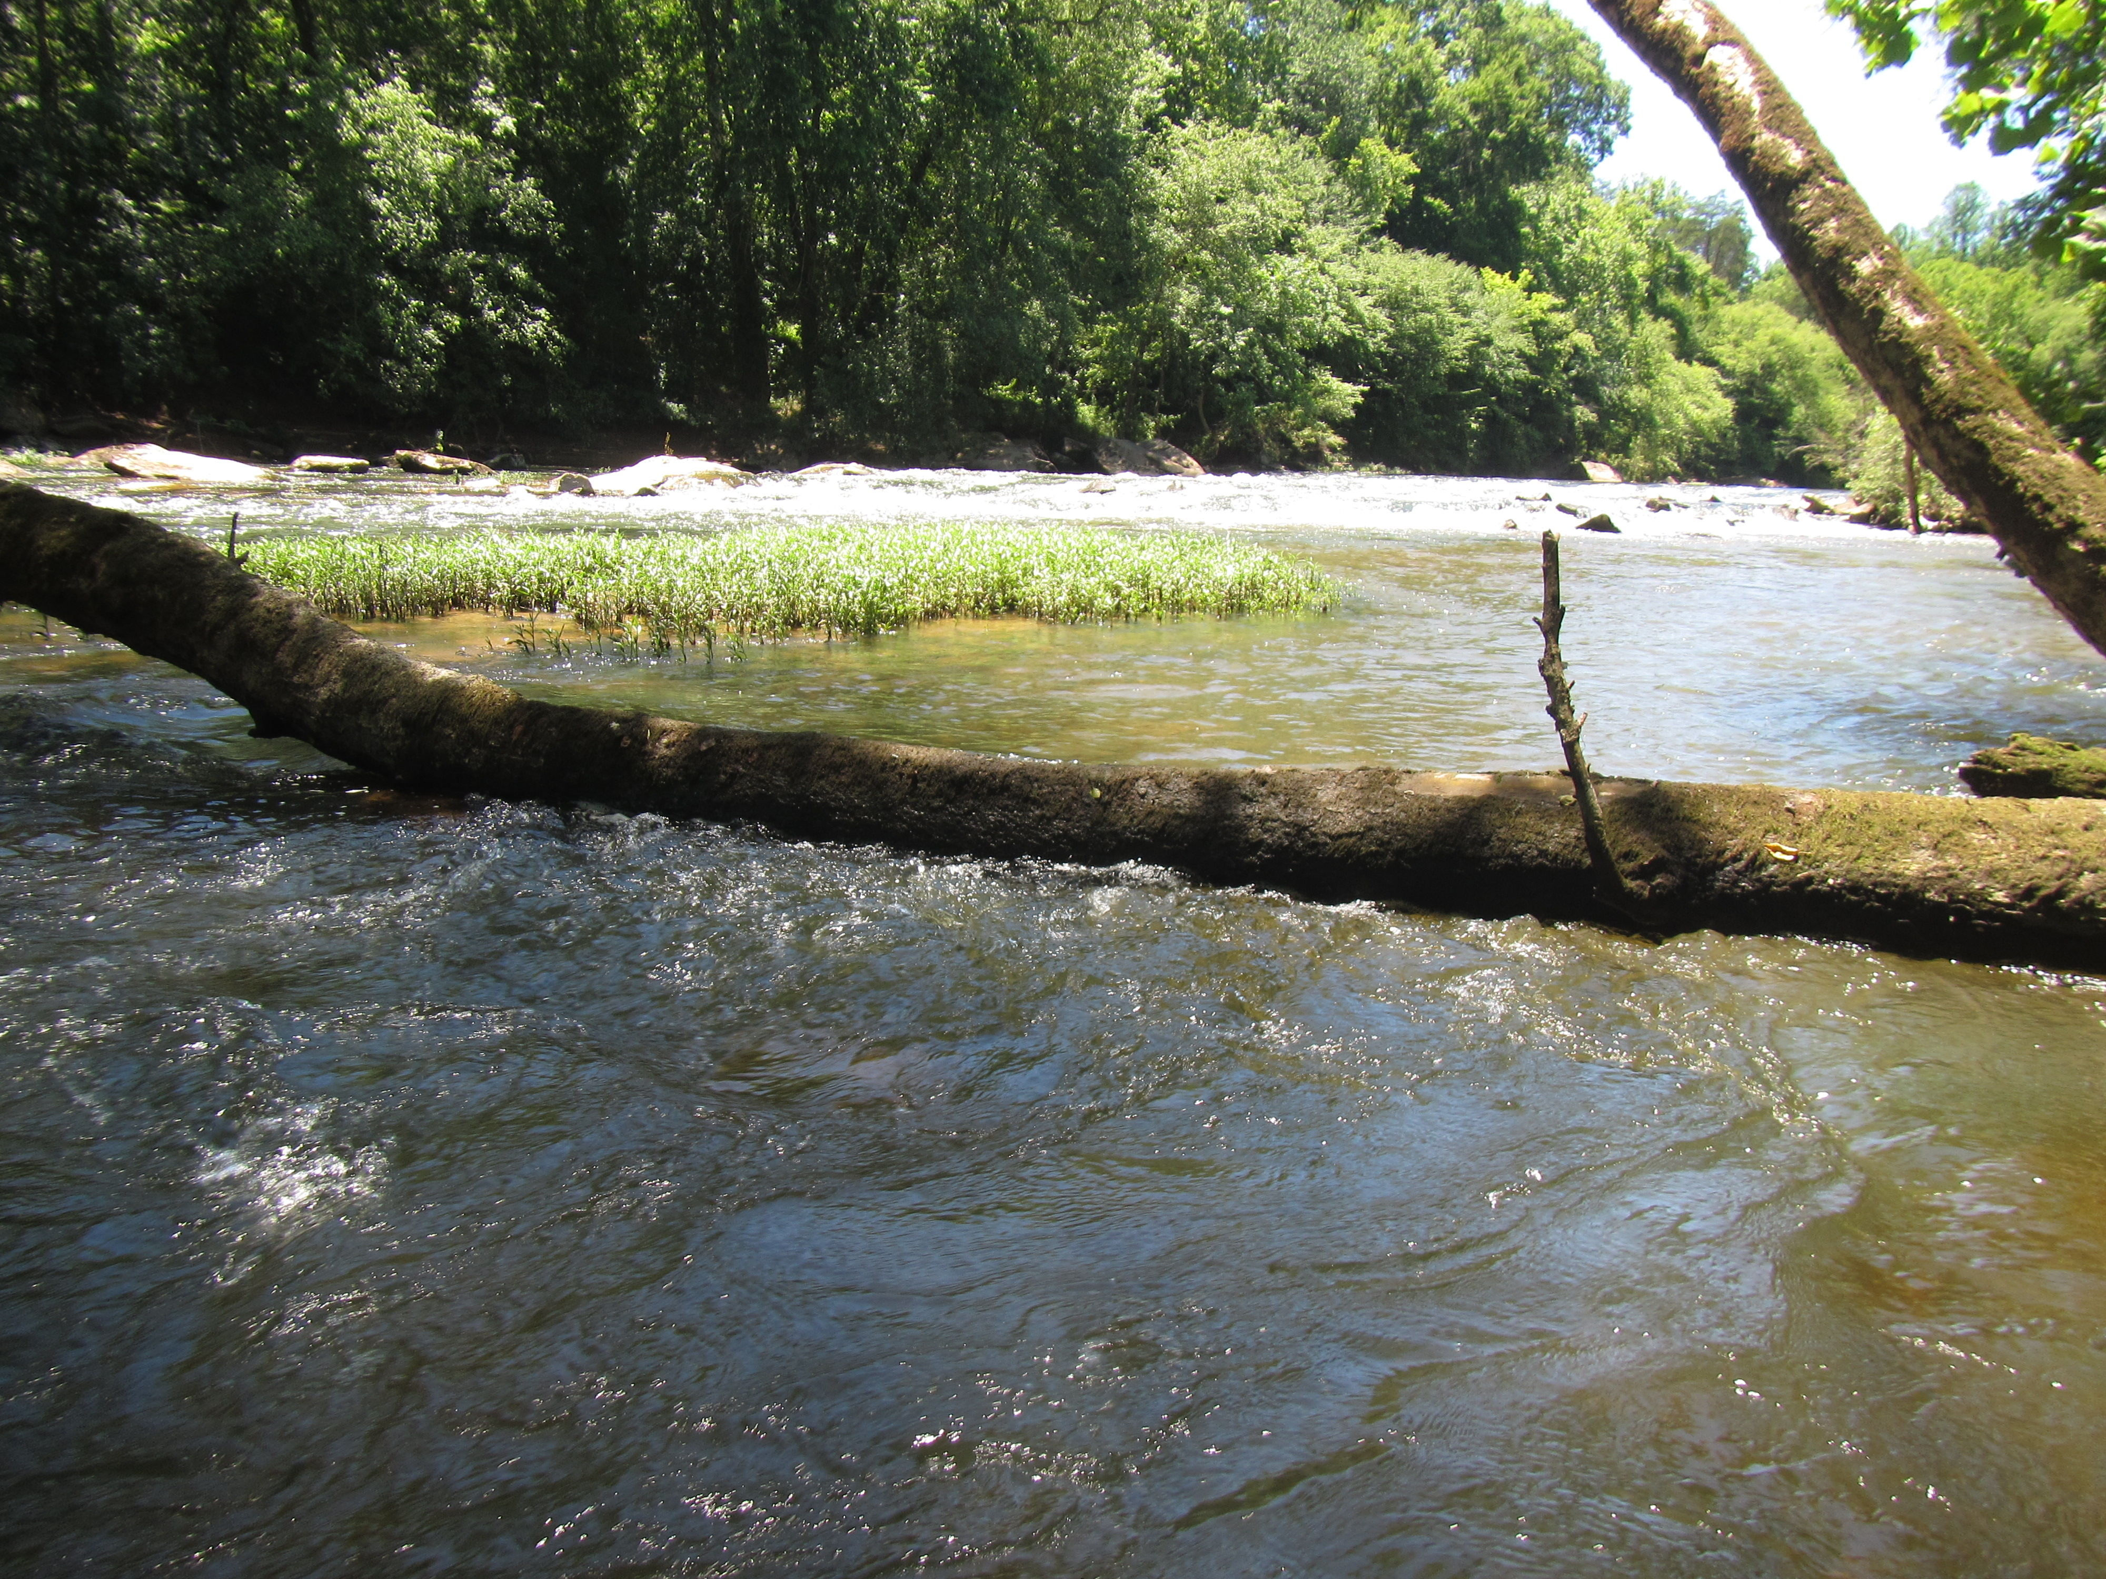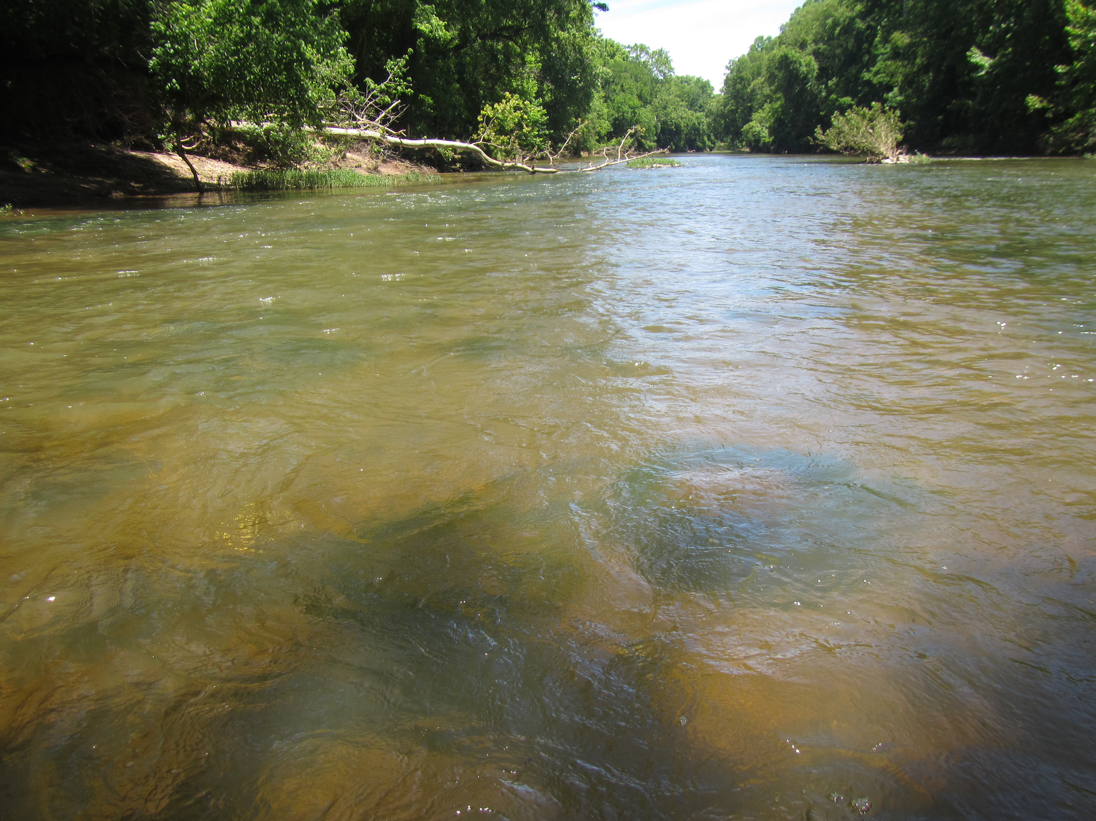
Figures 5 & 6. Possible high water and no riffles in sight.
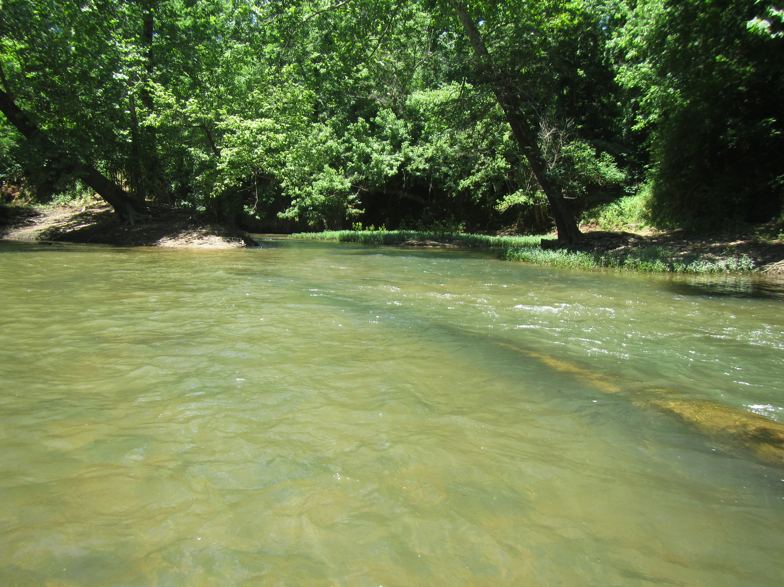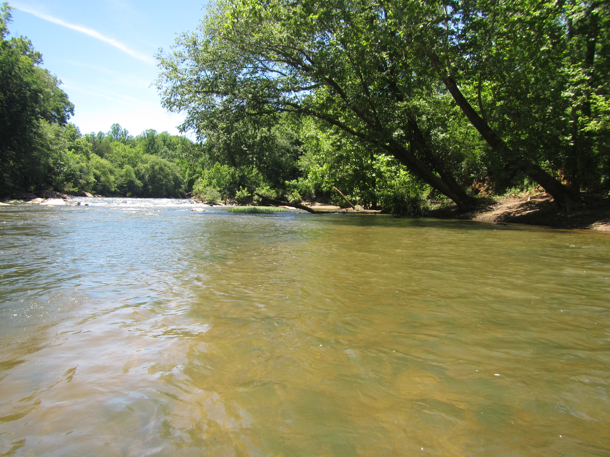
Figures 7 & 8. More possible high water with no sample-able riffles

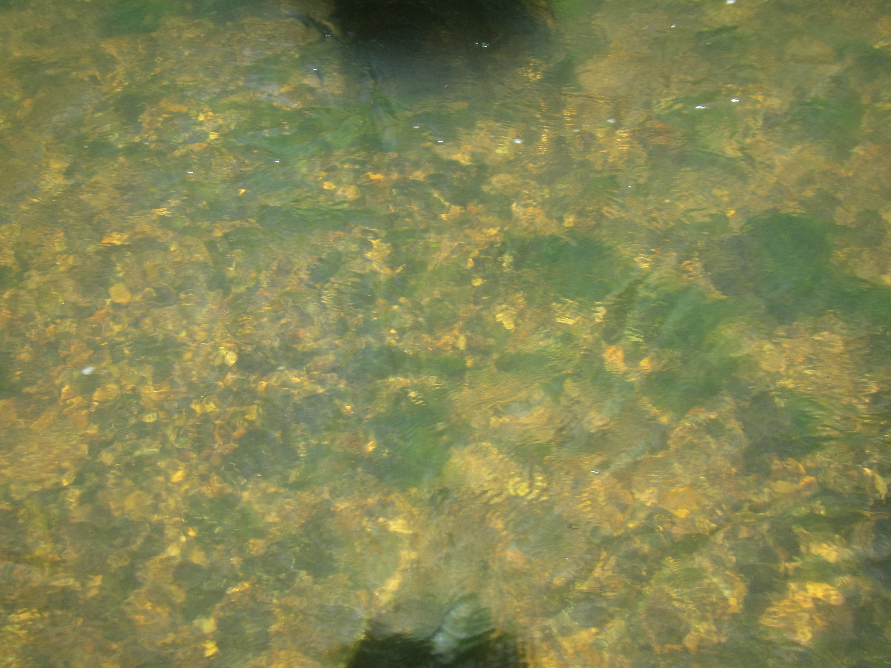
Figure 9. Rocks on the river bottom

