RIVANNA RIVER STEWARD REPORT
River Stewards: Dan Triman and Justin Altice Date: 6-15-16
Starting Location and Time: Darden Towe (10:00 AM)
Ending Location and Time: Riverview Park (11:30 AM)
Weather: Overcast Recent Precipitation: Not much rain recently
USGS Gauges: Earlysville 1.54 ft (48 ft³ / sec), Palmyra 3.20 ft (339 ft³ / sec),
Water Color: Mostly Clear Water Odor: None Air Temp. : 75 deg F
DO: 5 ppm PH: 8 Turbidity: 10 JTU Water Temp. : 26 deg C
Water Testing Location: Riverview Park below the steps at River Right
---------------------------------------------------------------------------------
Land Use:
Residential mainly, with some commercial use and park property

Wildlife Sightings and Plant Life:
Turtles, Crows, Fish, Geese, Ducks, and smaller birds. We also saw a couple of vultures eating the remains of a small dead animal just past Free Bridge (see photo below). Some invasives noticed on the banks, but also some native flowering plants. Lower water levels exposed a lot more underwater vegetation than we have seen recently.

People Interactions:
We saw 1 person fishing, a couple of people swimming at Riverview Park, and lots of people walking along the trails along the River. We also met with Charlottesville Parks and Rec today at Riverview Park to discuss fixing the stairs that are currently a safety issue for river access.

Litter and Pollution:
We removed about a ½ bag of trash from the Rivanna today, mostly bottles and cans, with a sports ball and a couple pieces of cardboard also. A couple of buried tires in the Rivanna were also found during the paddle.

Overall Summary:
Water levels are lower than they have been recently, but still were high enough to paddle without much issue. We met with Charlottesville Parks and Rec regarding the The Riverview Park steps and came up with a short term solution to provide better and safer river access from the park.

Actions Needed – level of priority (1 highest/5 lowest):
2 – Finalize plans to install new Riverview steps;

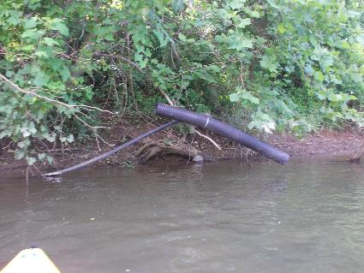
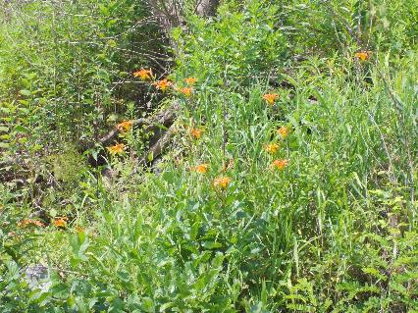
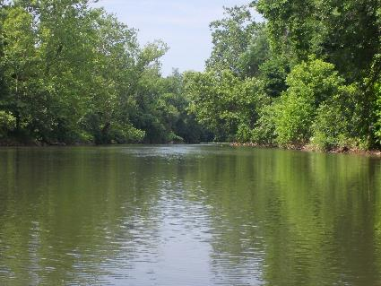
Figure 1: Orange lilies along the bank Figure 2: Pipe sticking up out of water near Darden Towe
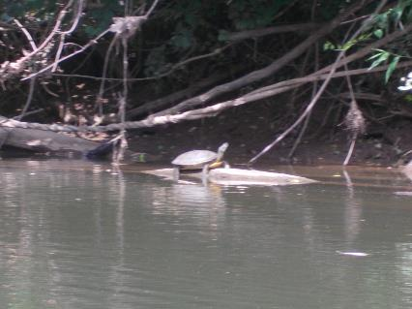
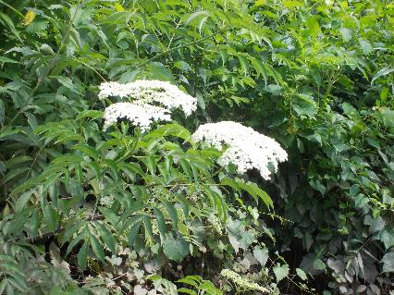
Figure 3: One of the many turtles seen today Figure 4: View of the river looking downstream
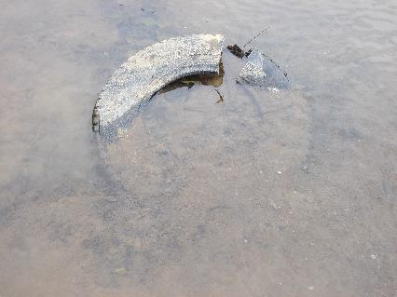
Figure 5: Buried tire in the River Figure 6: More vegetation along the banks

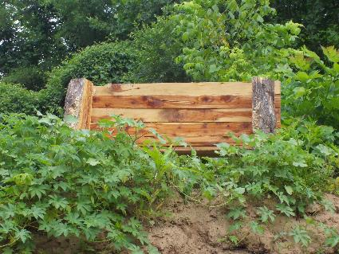
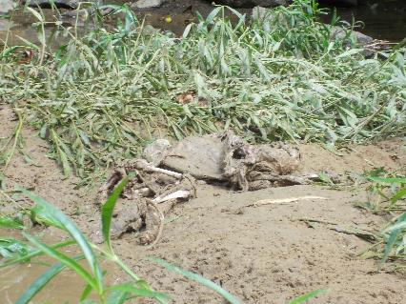
Figure 7: Remains of dead animal near Free Bridge Figure 8: Nice bench someone built along one of the banks
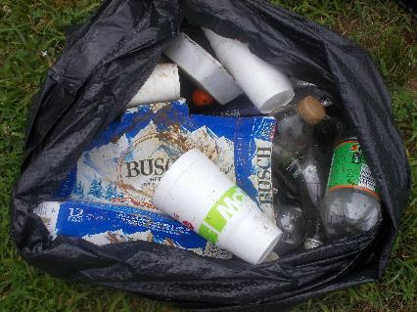
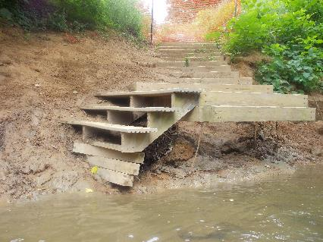
Figure 9: Riverview steps still in need of repair Figure 10: Trash collected during the paddle

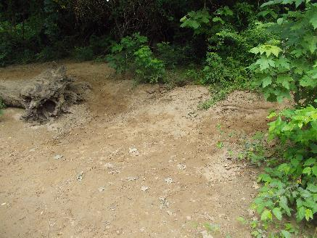
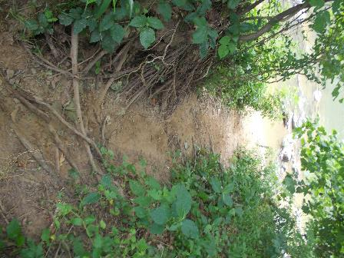
Figure 11: New path where steps will go at Riverview Figure 12: Location of new boat access point at Riverview

