RIVANNA RIVER STEWARD REPORT
River Stewards: Dan Triman and Justin Altice Date: 6-22-16
Starting Location and Time: Milton (11:00 AM)
Ending Location and Time: Crofton (3:00 PM)
Weather: Overcast Recent Precipitation: Fairly dry with some rain yesterday
USGS Gauges: Earlysville 1.65 ft (65 ft³ / sec), Palmyra 3.40 ft (450 ft³ / sec),
Water Color: Mostly Clear Water Odor: None Air Temp. : 80 deg F
DO: 5 ppm PH: 8 Turbidity: 10 JTU Water Temp. : 24 deg C
Water Testing Location: Crofton Boat Ramp River Left
---------------------------------------------------------------------------------
Land Use:
Mostly rural farms and wooded land, with some residential areas in Keswick and Lake Monticello.

Wildlife Sightings and Plant Life:
Turtles, Fish, Ducks, 1 Hawk, 1 Osprey, 1 Bald Eagle, 1 Green Heron, Smaller birds such as cardinals), 1 Deer, and 1 Woodpecker. Vegetation was very green and lush. Significant amount of large trees down in the River, but none blocking enough of River to prevent paddling past them.

People Interactions:
We were joined on this paddle by JD Brown (RCA Board Member), and Phyllis White (former RCS Board Member). We saw 1 person fishing near Crofton, but otherwise didn’t see any other people on the Rivanna today. There was one other car parked at Crofton when we finished out trip.

Litter and Pollution:
Removed 1 bag of trash from Rivanna today, mostly bottles and cans. Also saw 20-30 tires, and removed larger items such as a canoe paddle, boogie board, trash can lid, and kids sports equipment. Also a broken canoe and a piece of farm equipment (River left) identified that should be removed.

Overall Summary:
Water levels were good today and weather was nice for the paddle. Other than some trash, tires, and large trees down, this section of the Rivanna is in pretty good shape.

Actions Needed – level of priority (1 highest/5 lowest):
4 – Remove tires; 4 – Remove broken canoe and farm equipment; 3 – Look into repairing erosion at top of steps at Milton

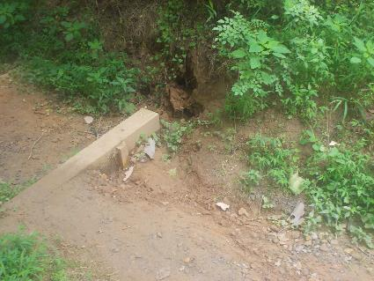
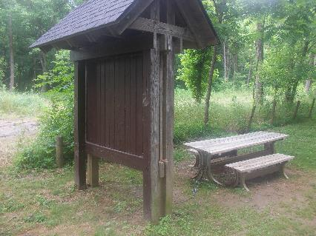
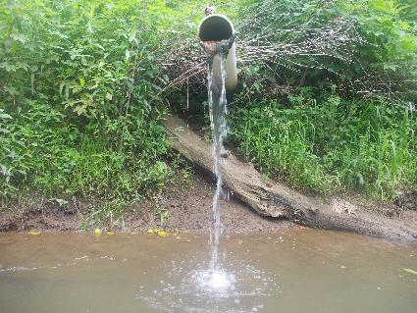
Figure 1: Kiosk and table at Milton in good shape Figure 2: Erosion at top of steps at Milton
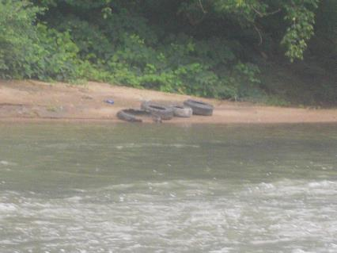
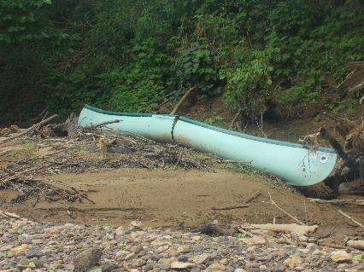
Figure 3: Tires on the bank across from Milton put in Figure 4: Pipe from Glenmore into the Rivanna River
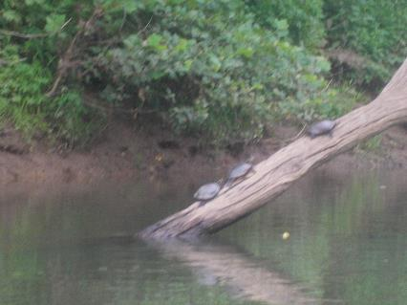
Figure 5: 3 Turtles on a log Figure 6: Broken canoe found during the paddle

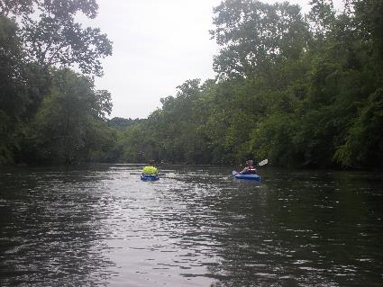
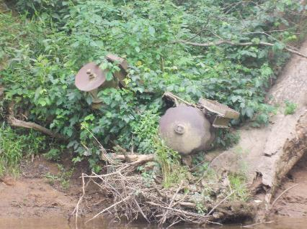
Figure 7: Piece of farm equipment found on river bank Figure 8: Justin and JD paddling
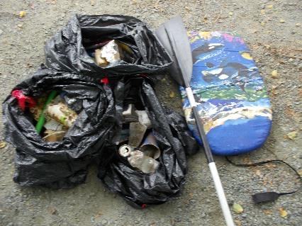
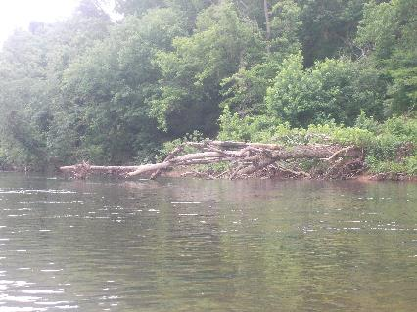
Figure 9: One of the many downed large trees found Figure 10: Trash collected during the paddle

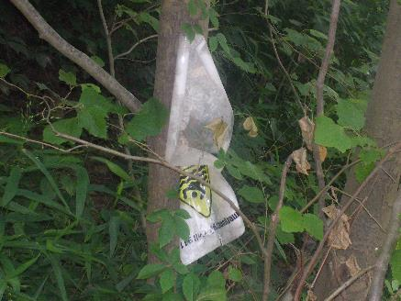
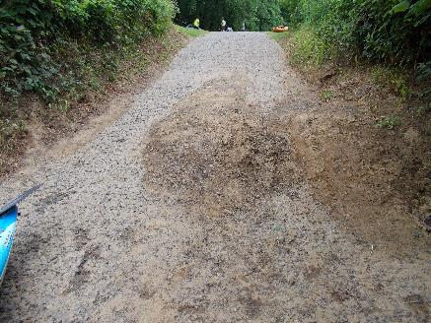

Figure 11: Sediment on Crofton boat ramp Figure 12: River 911 sign at Crofton that will be replaced soon

