RIVANNA RIVER STEWARD REPORT
River Stewards: Justin Altice Date: 06-3-16
Starting Location and Time: South Fork Rivanna Reservoir Dam (1:00 PM)
Ending Location and Time: Woodlands Rd Boat Ramp (3:30 PM)
Weather: Sunny with Overcast Sky Recent Precipitation: Rain Yesterday
USGS Gauges: Earlysville 1.96 ft (104 ft² / sec), Palmyra 4.32 ft (1190 ft² / sec),
Water Color: Brown Water Odor: Musty in spots Air Temp. : 85 deg F
DO: 4 ppm PH: 8 Turbidity: 40 JTU Water Temp. : 26 deg C
Water Testing Location: Woodlands Rd Bridge over Reservoir
---------------------------------------------------------------------------------
Land Use:
Residential around reservoir with a wooded buffer along edges.

Wildlife Sightings and Plant Life:
Turtles, Ducks, Geese, Crows, Small Birds, small fish jumping from water, and baby deer. Some grassy marshes along edges as well as some blooming foliage.

People Interactions:
Saw one other Kayaker and 3 fishermen in boats.

Litter and Pollution:
Minimal trash, a few plastic bottles and cigarette butts. A bit of trash at the Dam put-in which was placed in trash cans located there.

Overall Summary:
Extremely humid day, rains the previous evening left the Reservoir a bit murky with a film on top. Looked for any signs of Algae blooms in coves and corners of Reservoir as this is usually where it begins. None was found at this time; last year it began to be seen early July. Recent article in Cville paper mentioned the issue as a report had just been presented to RWSA Board. Started my paddle at the Dam and went up the Reservoir towards the South Fork origin. Many airplanes passed over due to the proximity to the airport. A few dead fish were seen and some land was noticed to have been cleared adjacent to Reservoir.

Actions Needed – level of priority (1 highest/5 lowest):
2– Continue to monitor the Reservoir for Algae Blooms
2 – Speak to County officials about poor condition and lack of parking at boat access point at Woodlands Rd.
3 – Check to see if land cleared is approved by locality.

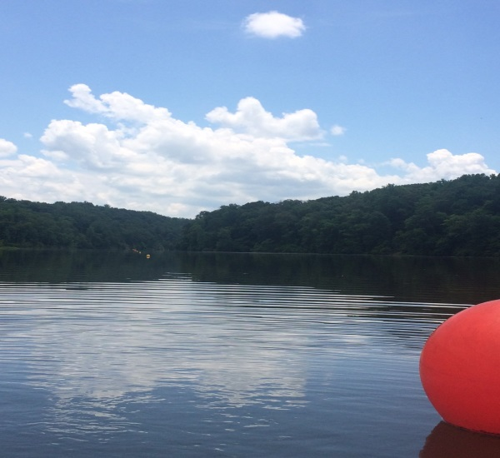
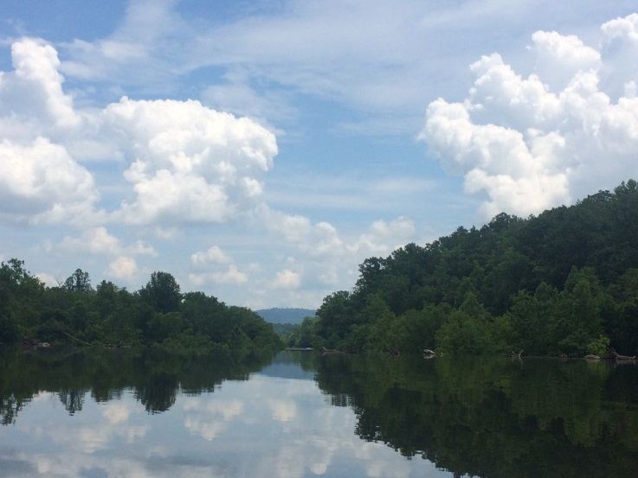
Figure 1: Look from Reservoir over the dam. Figure 2: Rowing club buoys.
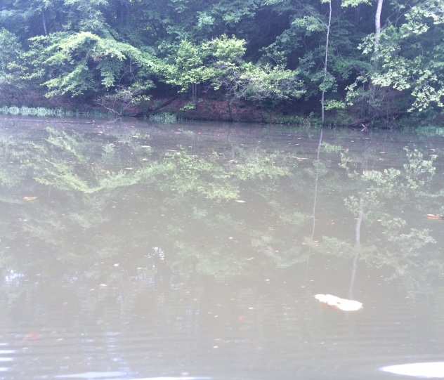
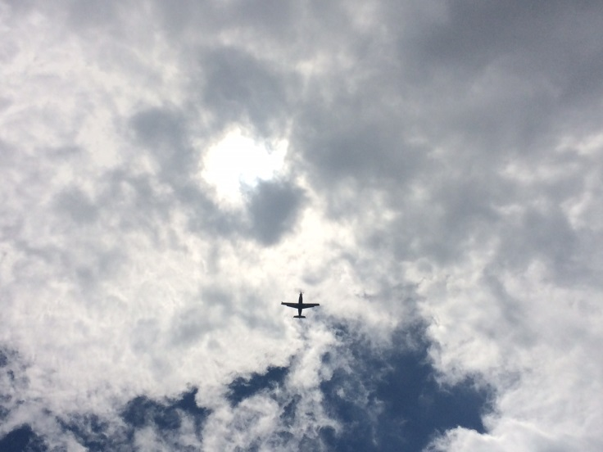
Figure 3: Planes flying over-head. Figure 4: Murky water with film on top.

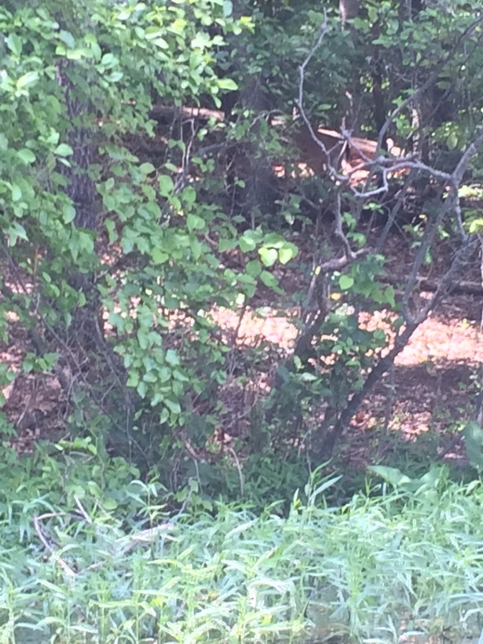
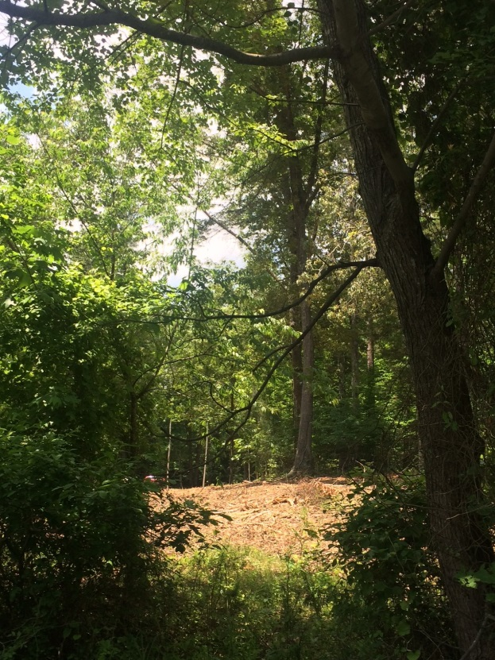
Figure 5: Land cleared along Reservoir. Figure 6: Can you see the baby deer?

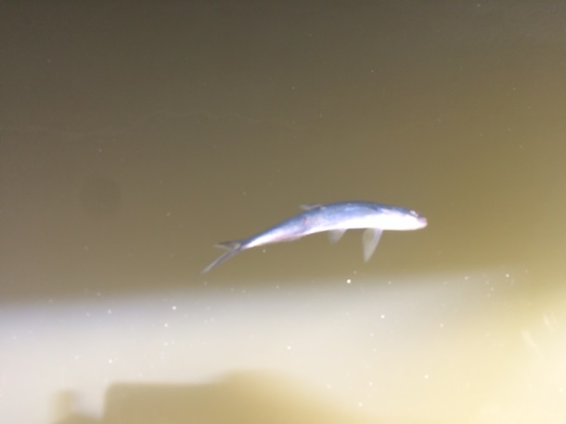
Figure 7: A few dead fish spotted.

