RIVANNA RIVER STEWARD REPORT
River Steward Name(s): Justin Altice Date: 07-1-15
Starting Location and Time: Rio Mills 4:30 AM
Ending Location and Time: Darden Towe 7:30 PM
Weather: Sunny with some overcast clouds Recent Precipitation: Lots of rain in recent weeks and a storm the night prior
Water Flow: Good current Water Color: Cloudy
Water Temp. : 76° F Air Temp. : 85° F
DO: 4 ppm PH: 8.0 Turbidity: 60 JTU
USGS Water Gauge Reading: Palmyra 3.8 ft
Physical Location Characteristics: Just below confluence of North and South Forks of Rivanna, near the tree blocking the river
Land Use:
Abundance of commercial use near 29, becoming more secluded in the middle of the paddle with scant residential development, then passing Pen Park and Darden Towe Park at the end

Wildlife Sightings and Plant Life:
Ducks, Turtles, Heron, Eagle, Geese, Snakes, Deer

People Interactions:
There was a family swimming and enjoying the river at Darden Towe pull out

Litter and Pollution:
Quite a bit of trash along the way; bottles, cans, oil containers, cooler lid. Really trashy spot where someone fishes along the river

Overall Summary:
River has a musty smell and a great deal of foamy bubbles up near the Rio Mills damn near all the 29 commercial development. It was a beautiful evening to be out on the river, with optimal water levels (good current), great weather (nice breeze), and good evening sun. A train passed over just as I was heading under railroad bridge which was unexpectedly nice. Lots of Mimosa Trees blooming and dropping their purple and pink blossoms into the river. Encountered a young deer out on an island in middle of the river.

Actions Needed – level of priority (1 highest/5 lowest)
4 – Identify access point for fishermen and try and follow-up about trash

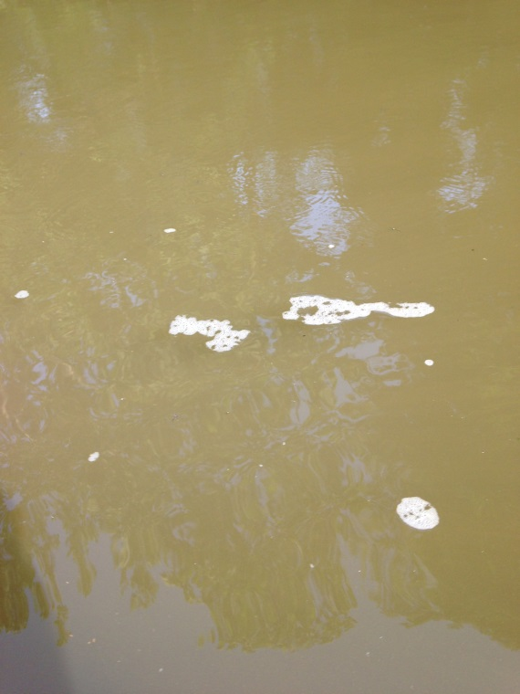
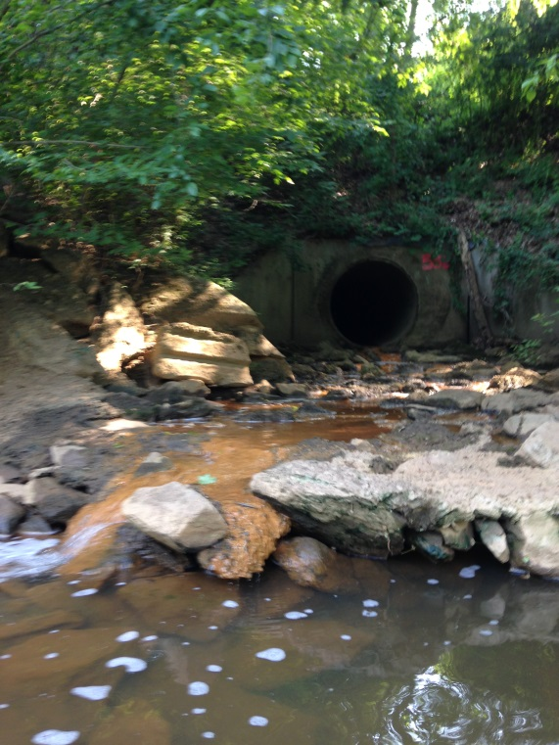
Figure 1: Pipe outfall coming from RT 29 development Figure 2: Foam bubbles prevalent near RT 29 stretch

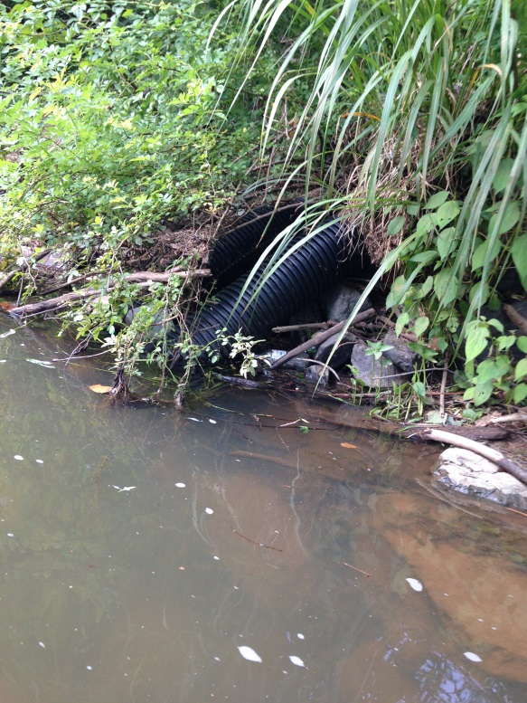
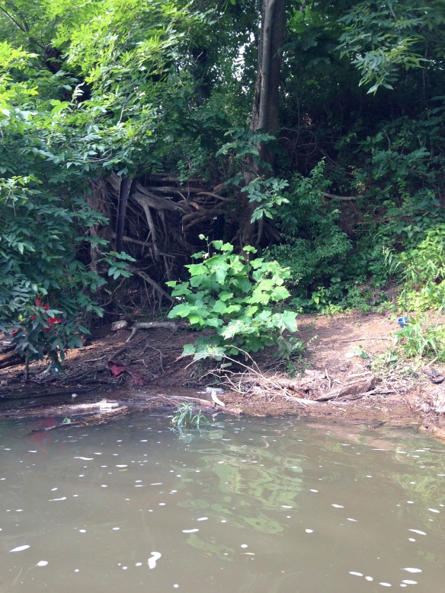

Figure 3: Fishermen area with lots of trash Figure 4: Pipes running into the river.

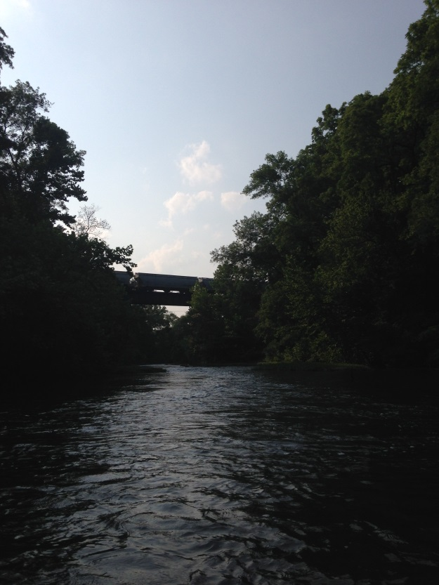
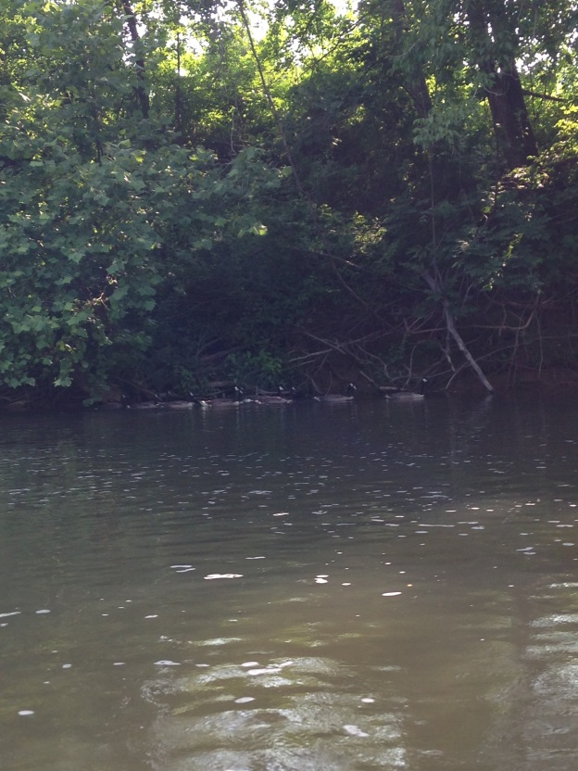
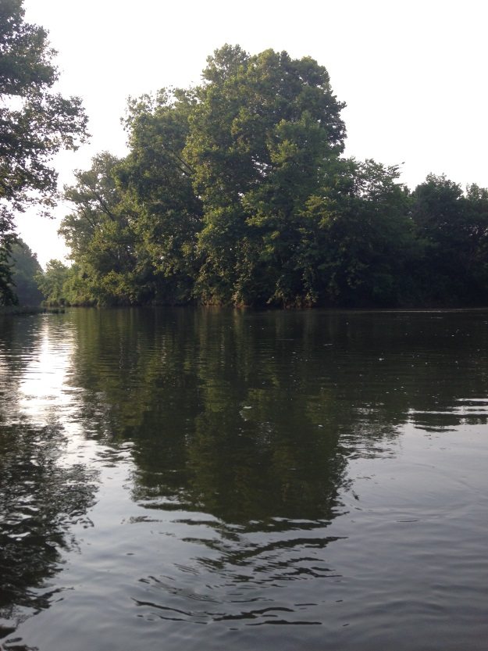
Figure 5: Geese Figure 6: Train going over the river. 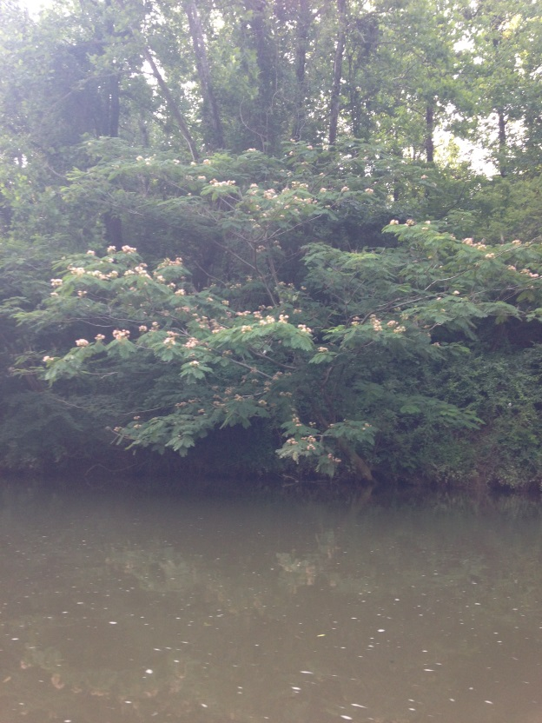
Figure 7: Mimosa Trees Figure 8: Confluence of North and South Forks.

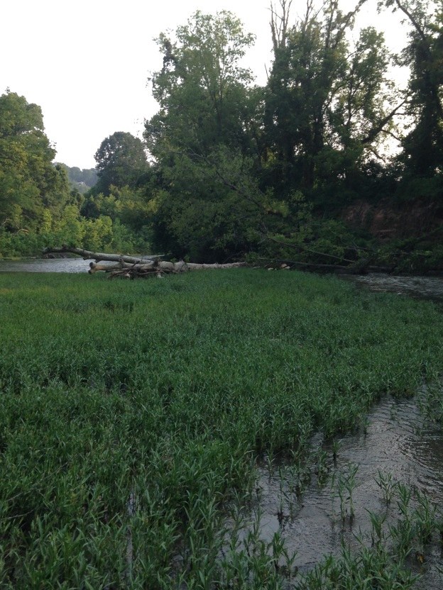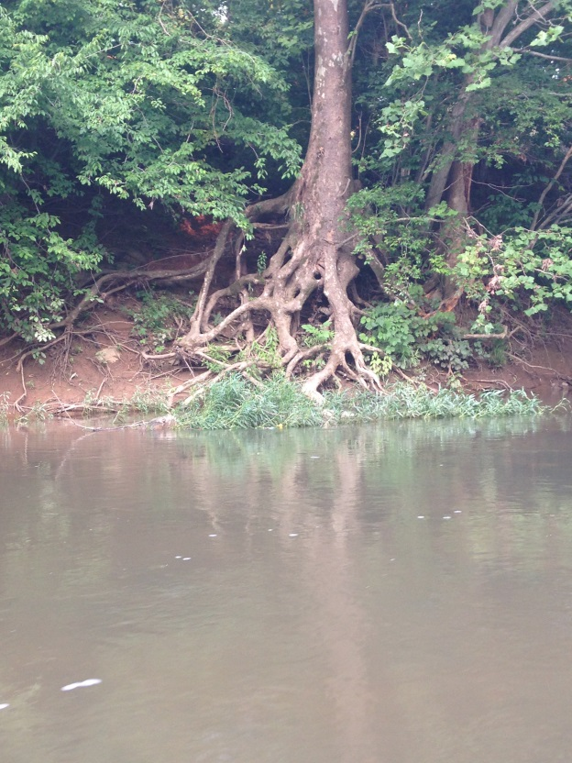

Figure 9: Tree blocking the river Figure 10: Tree Art

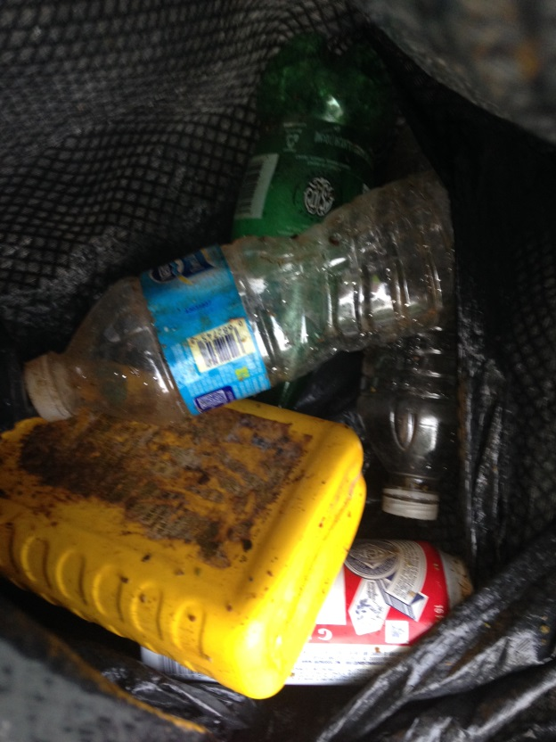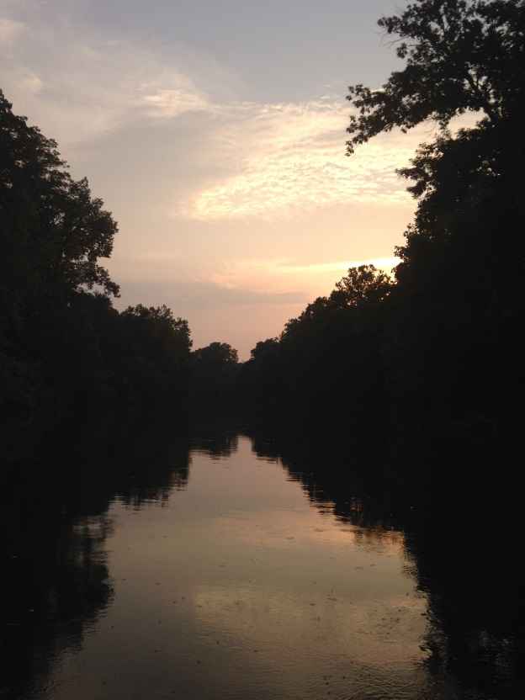

Figure 11: Trash. Figure 12: Sunset on the River!

