RIVANNA RIVER STEWARD REPORT
River Stewards: Justin Altice and Dan Triman Date: 07-10-16
Starting Location and Time: Rio Mills Bridge (4:00 PM)
Ending Location and Time: Darden Towe Park (7:000 PM)
Weather: Clear Sky Recent Precipitation: Hardly any rain recently
USGS Gauges: Earlysville 1.40 ft (33 ft² / sec), Palmyra 3.00 ft (200 ft² / sec),
Water Color: Clear Water Odor: None Air Temp. : 85 deg F
DO: 5 ppm PH: 9 Turbidity: 0 JTU Water Temp. : 29 deg C
Water Testing Location: 38°02.7’N 78°26.9’W River Left Lewis and Clark Center
---------------------------------------------------------------------------------
Land Use:
Float begins along 29 corridor with commercial use, then transitions to residential use along Polo Grounds Rd area, middle part of float contains open space while the end of the float goes through both Penn Park in the City and Darden Towe Park in the County

Wildlife Sightings and Plant Life:
Turtles, Crows, Green Heron, Small Birds, Turkey Vultures, Deer, Numerous Fish including many Long Nose Gar, Osprey. One dead young deer was seen in the water with 2 Turkey Vultures helping to clean it up. Very lush vegetation along the banks was seen today.

People Interactions:
We saw 10 people out fishing, 2 people stand up paddle boarding, 15 people tubing / rafting, and 3 people in canoes / kayaks.

Litter and Pollution:
Not much trash today, only a few cans and bottles. We also saw about 10 buried tires, and the piece of a car on the bank near Darden Towe.

Overall Summary:
Water levels were pretty low (almost too low for paddling), but the water was really clear, which was good for seeing numerous fish. Lots of people out enjoying the Rivanna today. We also checked out 3 trees down in the water near Lewis and Clark Center (see photos below). Bridge project near Dam has progressed further in recent months (see photo below).

Actions Needed – level of priority (1 highest/5 lowest):
4 – Remove tires and piece of car

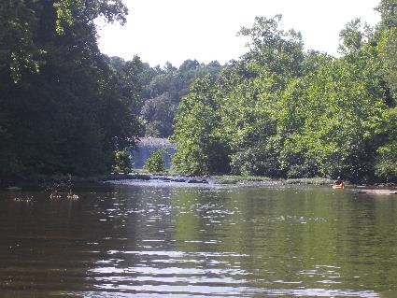
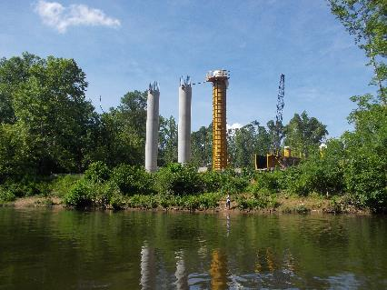
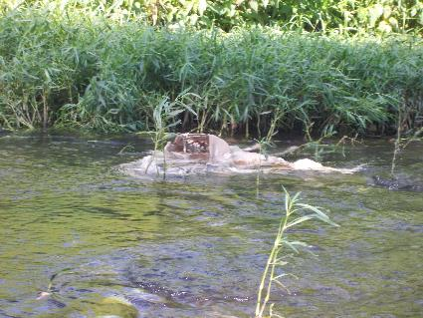
Figure 1: Bridge project just below the Dam Figure 2: View of the Dam looking upstream
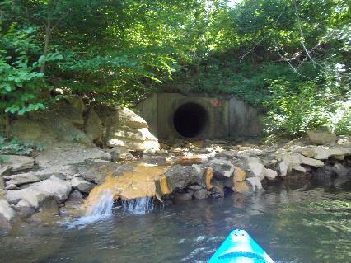
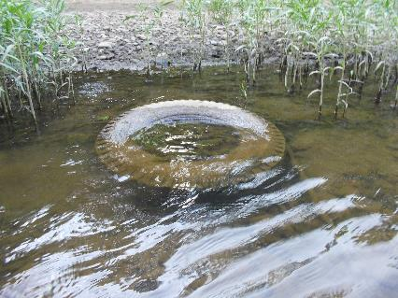
Figure 3: Pipe from shopping center below 29 bridge Figure 4: Dead deer found in the river
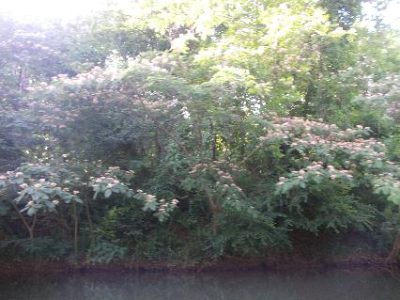
Figure 5: Lots of mimosa trees in bloom today Figure 6: One of the buried tires in the river

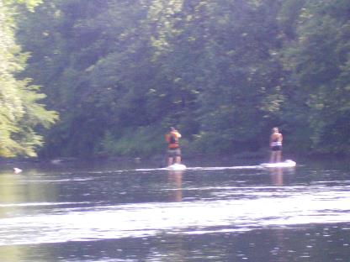
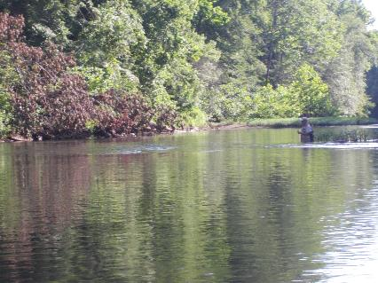
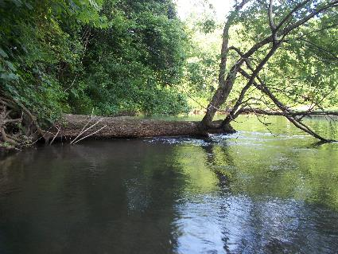
Figure 7: Person fishing in the Rivanna Figure 8: Stand up paddle boarders
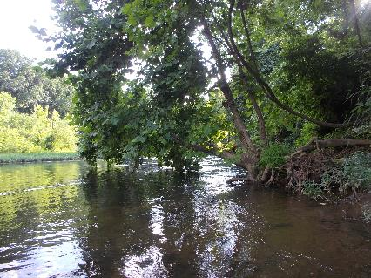
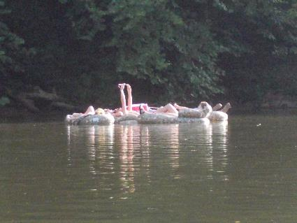
Figure 9: 1st of 3 trees near Lewis + Clark Center Figure 10: 2nd of 3 trees (looking upstream)
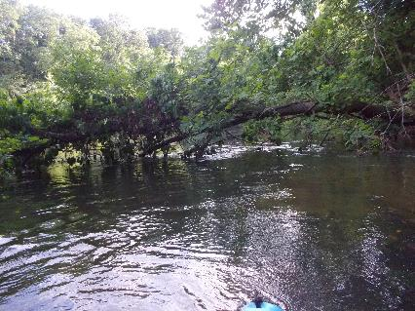
Figure 11: 3rd of 3 trees near Lewis + Clark Center Figure 12: Some of the tubers we saw today

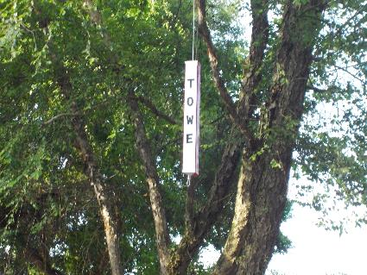
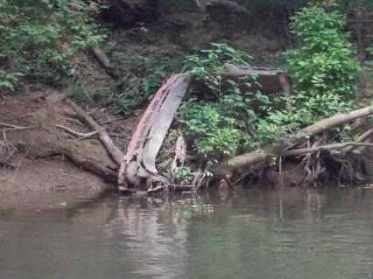
Figure 13: Piece of a car on the bank above Darden Towe Figure 14: Newly placed marker for Darden Towe take out

