RIVANNA RIVER STEWARD REPORT
River Stewards: Dan Triman and Justin Altice Date: 07-23-16
Starting Location and Time: Crofton (9:30 AM)
Ending Location and Time: Palmyra (12:30 PM)
Weather: Sunny Recent Precipitation: Hardly any rain the past few weeks
USGS Gauges: Earlysville 1.25 ft (22 ft³ / sec), Palmyra 2.70 ft (105 ft³ / sec),
Water Color: Very clear Water Odor: None Air Temp. : 90 deg F
DO: 4 ppm PH: 7 Turbidity: 0 JTU Water Temp. : 31 deg C
Water Testing Location: Palmyra Boat Ramp River Right
---------------------------------------------------------------------------------
Land Use:
Mostly open space and wooded areas, with some farms and residential.

Wildlife Sightings and Plant Life:
Turtles, Bass, Catfish, Gar, Geese, Ducks, Beaver, Smaller birds such as Blue Jays and Tree Swallows, Butterflies, and Dragonflies. Large variety of vegetation along the banks, and some under water. Several large downed trees in the River as well, but none blocking the paddling routes.

People Interactions:
The Rivanna was full of people enjoying some reprieve from the heat today. We saw about 30 other people on the River today, some of which were fishing, some kayaking, and some swimming in the River.

Litter and Pollution:
We removed ½ a bag of trash from the River. It was mostly cans and bottles. Also noticed about 10-15 tires buried in the River.

Overall Summary:
We were joined on the paddle by 2 other people. The water levels continue to be extremely low and are just about as low as still allows for paddling without too much trouble. The water is still very clear, which allowed us to see numerous fish swimming around today. Probably saw the most number of people we have ever seen at the Crofton put in location. Other than the tires we saw this stretch looked pretty clear of trash. New 911 signs have been placed recently at Palmyra and Pleasant Grove by RCA.

Actions Needed – level of priority (1 highest/5 lowest):
4 – Remove remaining tires from the River

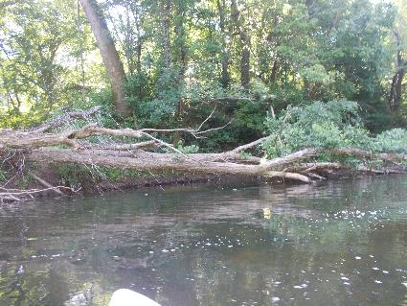
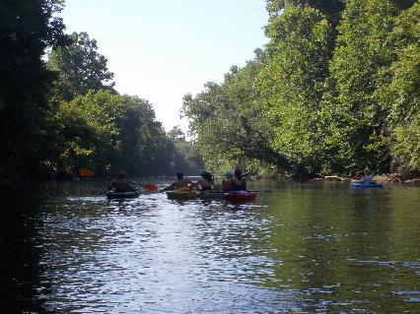
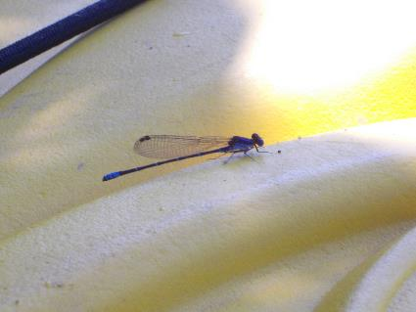
Figure 1: One of the large groups of people we saw today Figure 2: One of the large trees down in the River
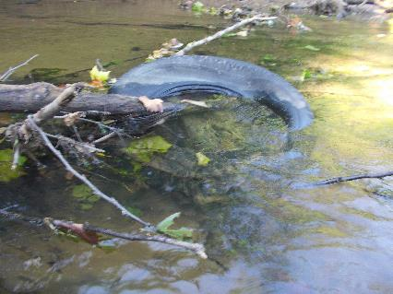
Figure 3: One of the buried tires identified Figure 4: Passenger on the kayak
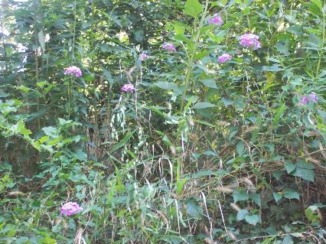
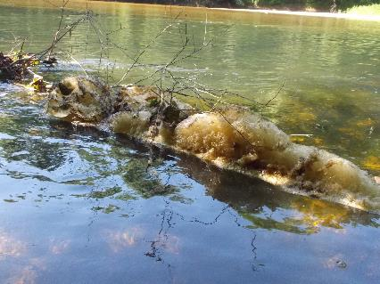
Figure 5: Foam build up found in a couple of locations Figure 6: Purple flowers along the bank

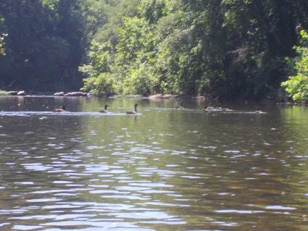
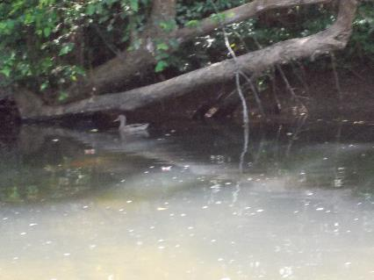
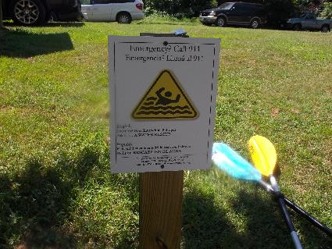
Figure 7: Duck swimming in the River Figure 8: Geese near Pleasant Grove
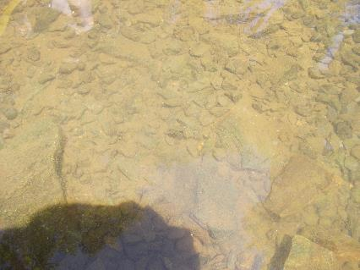
Figure 9: Example of how clear the water was today Figure 10: New RCA Emergency 911 sign at Palmyra

