RIVANNA RIVER STEWARD REPORT
River Steward Names: Dan Triman and Justin Altice Date: 07-28-15
Starting Location and Time: Darden Towe Park (7:00 PM)
Ending Location and Time: Riverview Park (8:00 PM)
Weather: Heavy Rain and Thunder Recent Precipitation: Significant amount
Water Flow: Very Fast Water Color: Brown Water Odor: None
Water Temp. : 25 deg C Air Temp. : 80 deg F
DO: 5 ppm PH: 8 Turbidity: 60 JTU
USGS Water Gauge Readings: Earlysville 3.60 ft, Palmyra 3.60 ft
Physical Location Characteristics: Darden Towe Park
Location Tested: At boat ramp put in River Left
---------------------------------------------------------------------------------
Land Use:
Residential mainly, with some commercial use

Wildlife Sightings and Plant Life:
No wildlife seen during our outing. Plants around and in the River looked very robust due to recent rain.

People Interactions:
Saw a few people running on the trails at Riverview Park.

Litter and Pollution:
We didn’t notice a whole lot of trash in the River.

Overall Summary:
We set out to do the paddle trip from Darden Towe Park to Riverview Park, but we ran into a severe rain and thunderstorm, so instead we just walked along some of the trails next to the River to see how things looked during the strong rainstorms. The water was moving really fast, and was a brownish color. Lots of runoff coming from the surrounding land on the banks of the River. We got a little wet during the outing, but it was interesting to see the River and the runoff entering the River during a strong rain event. We took some photos of the River and stormwater runoff we saw along the way (see below).

Actions Needed – level of priority (1 highest/5 lowest):
None.

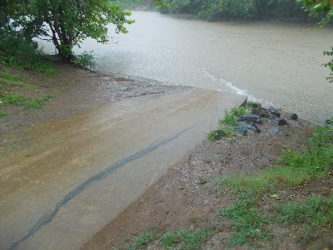
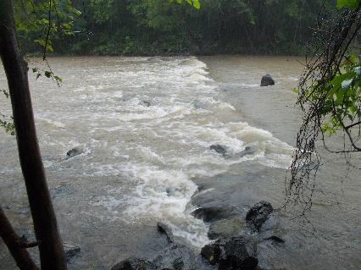
Figure 1: Rapid just above Darden Towe boat put in Figure 2: Stormwater runoff sheet flow on boat ramp
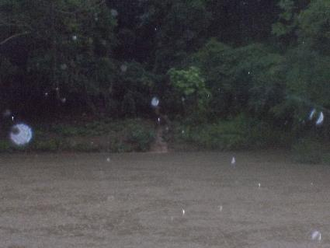
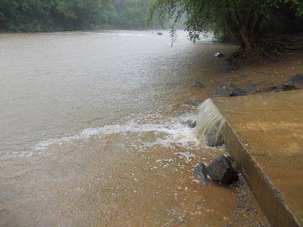
Figure 3: Runoff from Darden Towe parking lot Figure 4: Runoff out of pipe across the River at Darden Towe

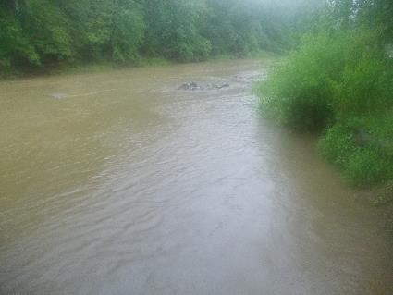
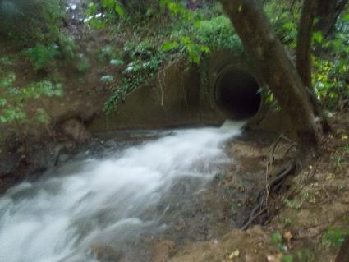

Figure 5: Runoff from pipe under Free Bridge Figure 6: View of the Rivanna near Riverview Park.

