RIVANNA RIVER STEWARD REPORT
River Stewards: Justin Altice Date: 08-07-16
Starting Location and Time: Reas Ford Road Bridge (4:45 PM)
Ending Location and Time: South Fork Rivanna Reservoir Dam (7:45 PM)
Weather: Sunny Recent Precipitation: Previous rain of 0.5 inch the week leading up to paddle
USGS Gauges: Earlysville 1.4 ft (28 ft³ / sec), Palmyra 4.2 ft (1000 ft³ / sec),
Water Color: Murky Water Odor: None Air Temp. : 85 deg F
DO: 5 ppm PH: 7 Turbidity: 30 JTU Water Temp. : 80 deg F
Water Testing Location: Dam
---------------------------------------------------------------------------------
Land Use:
Mostly open space with a few residential dwelling as you move towards the dam. Panorama Farms owns the majority of the waterfront land on south shoreline of the reservoir.

Wildlife Sightings and Plant Life:
Turtles, herons, osprey, crows, ducks, geese, and a hawk. Numerous grasses grow along the reservoir shoreline that is unique to this area.

People Interactions:
Saw two kayakers at Reas Ford Rd put in and then numerous fishermen along the shoreline near Reas Ford. Saw numerous people fishing from the Earlysville Rd bridge to the dam.

Litter and Pollution:
Collected a half a bag of trash at Reas Ford put in, then collected a few bottles and cans along the reservoir.

Overall Summary:
The weather on Sunday was sunny and less humid than previous days which offered a great day to paddle. I paddled east towards the dam so that the sun, which was setting would be shining the opposite way. Overall the reservoir was clear of trash with the only trouble spots being near Reas Ford Rd where many folks fish.
I did see signs of algae beginning to grow in some of the corners of the Reservoir. The area around the UVa boat dock had a layer of thick algae.
Also a boat was observed fishing right against the dam, well beyond the restricted buoys.

Actions Needed – level of priority (1 highest/5 lowest):
3 – Algae in Reservoir needs to be reported to RWSA;
2 – Look into ways to increase trash removal by fishermen.

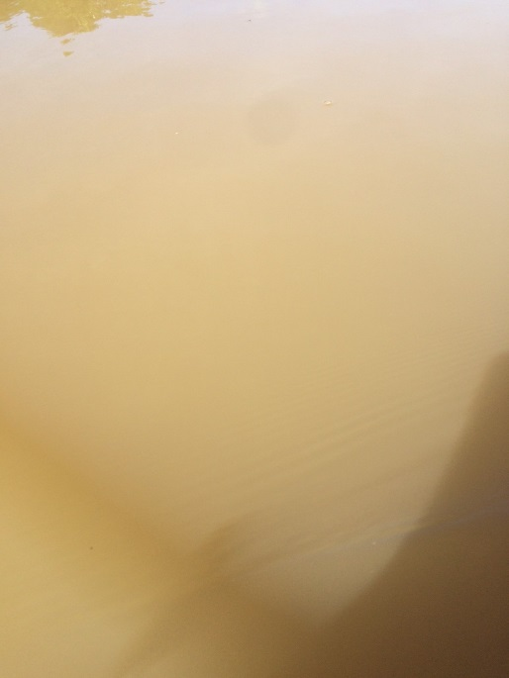
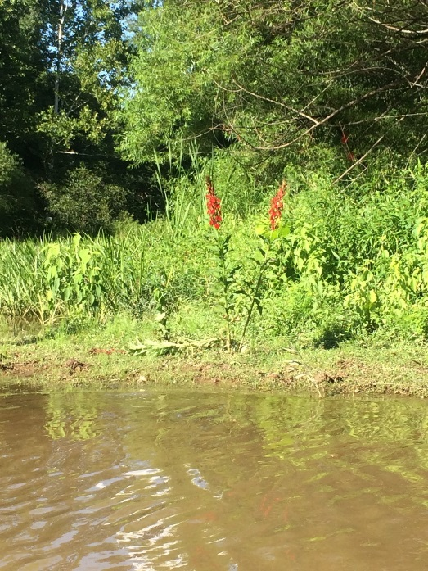
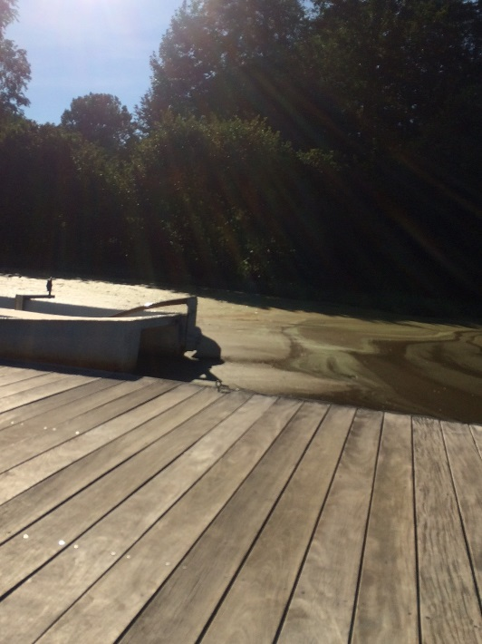
Figure 1: Foliage bloom on shoreline. Figure 2: Murky water
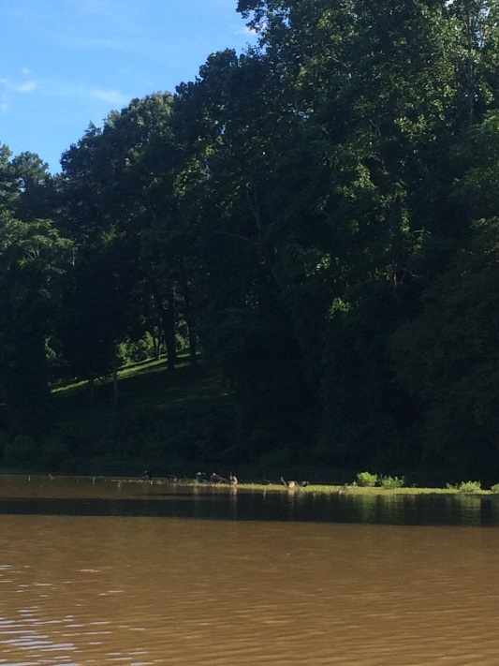
Figure 3: Swans and ducks hanging out. Figure 4: Algae found near UVa Boat dock.

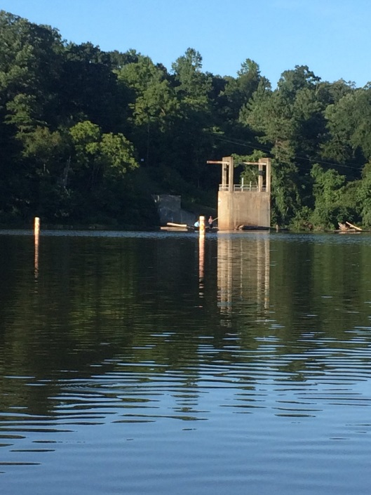
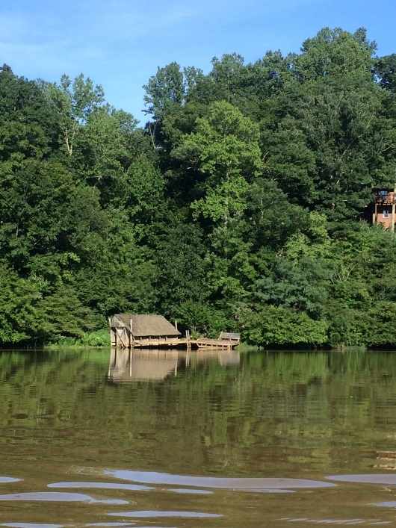
Figure 5: Dilapidated dock along reservoir. Figure 6: Boater fishing well beyond no entry buoy.

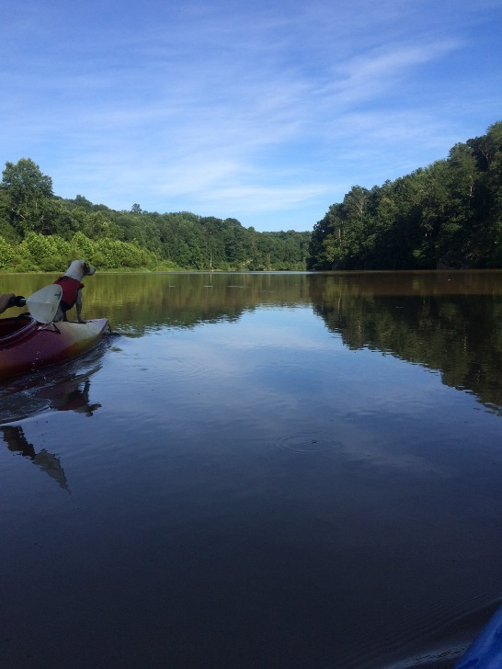
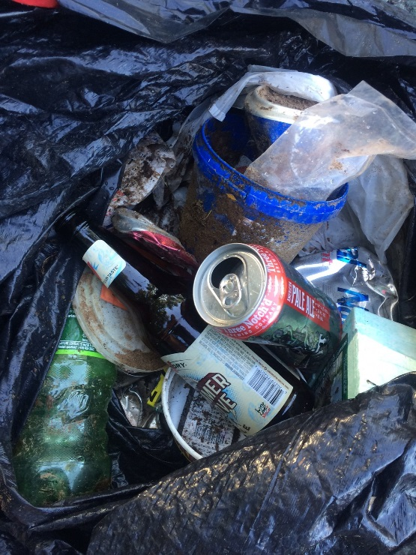
Figure 7: Trash removed, mostly at Reas Ford. Figure 8: Kayaker with Jack Russell captaining the ship.

