RIVANNA RIVER STEWARD REPORT
River Stewards: Dan Triman and Justin Altice Date: 08-10-16
Starting Location and Time: North Fork – Frays Mill Rd (9:45 AM)
Ending Location and Time: North Fork - 29 (12:30 PM)
Weather: Sunny / Clear Skies Recent Precipitation: Some rain the last week
USGS Gauges: Earlysville 1.34 ft (29 ft³ / sec), Palmyra 3.27 ft (357 ft³ / sec),
Water Color: Clear Water Odor: None Air Temp. : 85 deg F
DO: 4 ppm PH: 7 Turbidity: 10 JTU Water Temp. : 24 deg C
Water Testing Location: Just below Dickerson Rd Bridge – River Left
---------------------------------------------------------------------------------
Land Use:
Mostly private land, with some farms and residential. Good vegetation buffer around the River for the whole stretch of the Rivanna.

Wildlife Sightings and Plant Life:
Turtles, Fish, Ducks, Smaller birds, Butterflies, Dragonflies, Spiders, and 1 Heron. Vegetation along the banks and underwater was very lush and abundant. Several large downed trees in the water, with one blocking the entire River. Several severely eroded banks were found during the paddle.

People Interactions:
The only other person we saw during the trip was one person fishing at the damn at Frays Mill Rd, who said he lived just up the road.

Litter and Pollution:
There was significant trash found at Frays Mill Dam, Dickerson Rd Bridge, and the Dam just above the 29 bridge. We removed about 2 bags full of trash from these areas. We found about 5 tires buried in the River as well. We also found 2 sandbags remaining from the construction project near the 29 bridge. Otherwise the river was free of trash and pollution.

Overall Summary:
We paddled a 3 mile portion of the North Fork of the Rivanna. It turned out the water levels were just high enough to do the paddle. The water was very clear in most locations and other than a few large trees down, the area we paddled was in really good shape. Very peaceful on this stretch.

Actions Needed – level of priority (1 highest/5 lowest):
3 – Remove tires from the River.
3 – Remove the one large tree blocking the entire River.

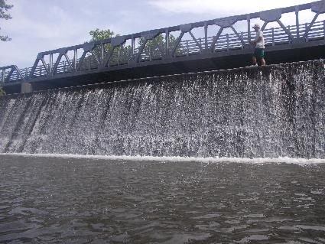
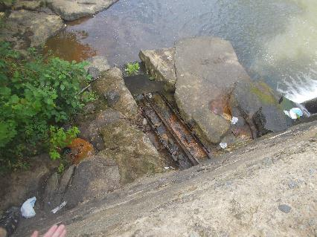
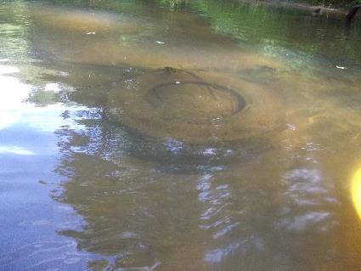
Figure 1: Trash found at Frays Mill Dam Figure 2: View of the Frays Mill Dam from below
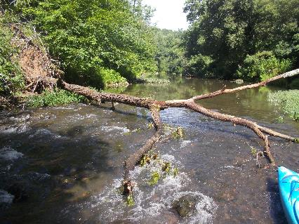
Figure 3: Large tree down blocking the River Figure 4: One of the buried tires found
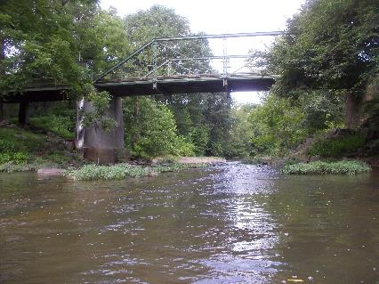
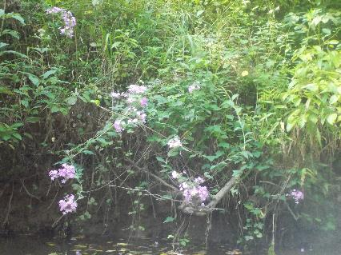
Figure 5: Purple flowers in bloom along the bank Figure 6: View of Dickerson Rd Bridge

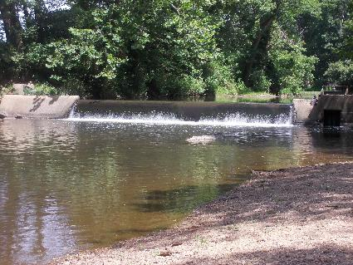
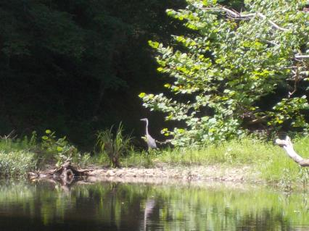
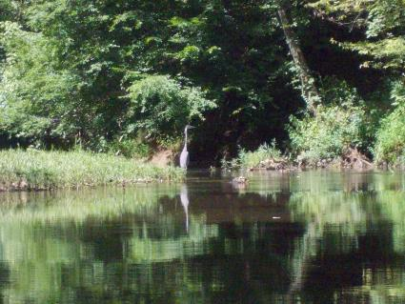
Figure 7: Heron standing next to the River Figure 8: View of the Dam just above the 29 Bridge
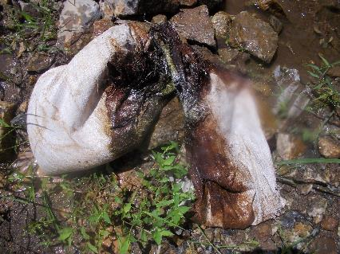
Figure 9: Sandbags pulled out of River near 29 Bridge Figure 10: Another shot of the Heron

