RIVANNA RIVER STEWARD REPORT
River Stewards: Dan Triman Date: 08-26-16
Starting Location and Time: North Fork – Proffit Rd (7:45 AM)
Ending Location and Time: Darden Towe Park (11:15 AM)
Weather: Sunny / Clear Skies Recent Precipitation: Mostly dry recently
USGS Gauges: Earlysville 1.11 ft (12 ft³ / sec), Palmyra 2.62 ft (123 ft³ / sec),
Water Color: Clear Water Odor: None Air Temp. : 85 deg F
DO: 4 ppm PH: 7 Turbidity: 10 JTU Water Temp. : 28 deg C
Water Testing Location: Proffit Rd Bridge – River Right on the North Fork
---------------------------------------------------------------------------------
Land Use:
Between Proffit Road and the confluence with the South Fork, mostly private property (residential and agricultural), then becomes a mix of park land and private residential property closer towards Darden Towe Park.

Wildlife Sightings and Plant Life:
Turtles, Fish, Geese, Smaller birds, Butterflies, Dragonflies, Spiders, 2 Osprey, 2 Great Blue Herons, 3 Green Herons, and several frogs and toads. The North Fork section had severely eroded banks and therefore numerous location of large downed trees blocking the entire River.

People Interactions:
Saw a few people out with their dogs today and 1 person fishing.

Litter and Pollution:
A few cans and bottles found during paddle. Removed 3 tires (of the 6 seen), inner tube, wheelbarrow, and kids bicycle. Also removed a full trash bag worth of items from across the River at the Darden Towe boat ramp.

Overall Summary:
Paddled the 2 miles of the North Fork from Proffit Rd, and then another 3 miles from the Confluence with the South Fork to Darden Towe Park. It was very hot today, so good to be out in the morning. Water levels are really low and meant walking the kayak many times. The water was very clear in most locations. Numerous trees down blocking the River on the North Fork section, and a lot of erosion on the banks there as well.

Actions Needed – level of priority (1 highest/5 lowest):
3 – Remove tires; 3 – Remove the large trees blocking the entire River in 4 locations on the North Fork; 3 – Remove large tank (see photo)

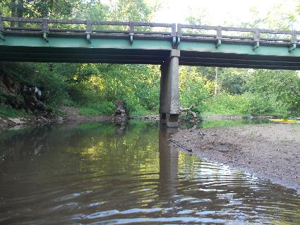
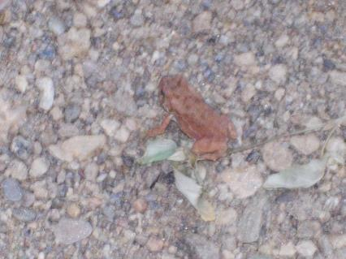
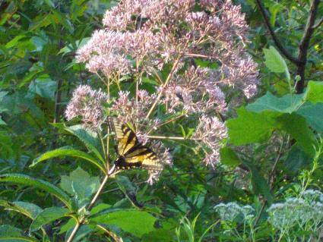
Figure 1: Frog or Toad found at Proffit Rd Bridge Figure 2: View of Proffit Rd Bridge
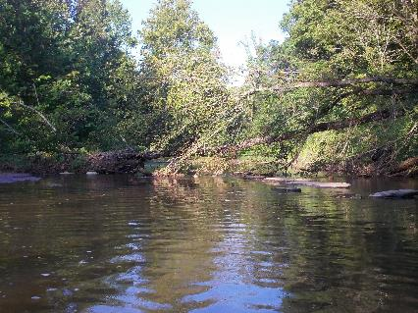
Figure 3: One of the trees down blocking the River Figure 4: Butterfly spotted along the banks
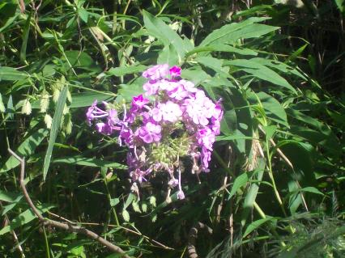
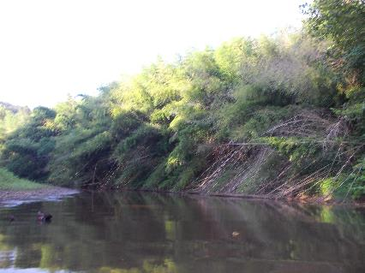
Figure 5: Extensive patch of bamboo near Proffit Rd Figure 6: Flowers seen along the banks

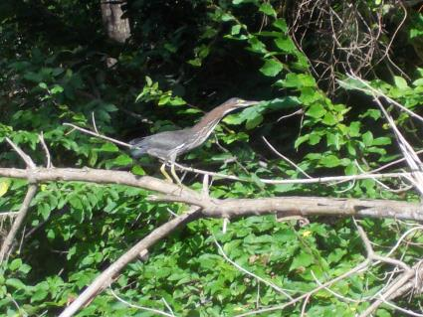
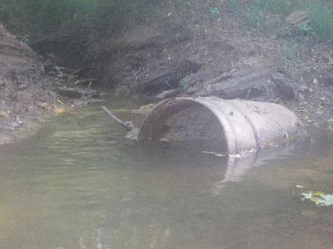
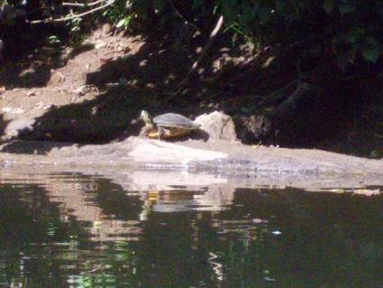
Figure 7: Large tank/container in the River Figure 8: Green Heron on a tree
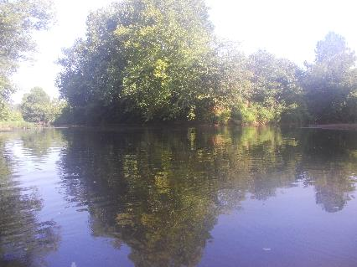
Figure 9: Confluence of North and South Forks Figure 10: Turtle on a log

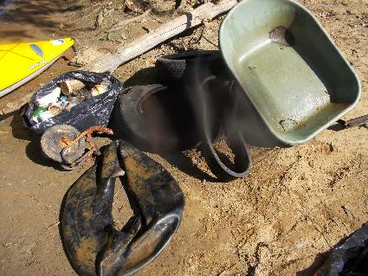
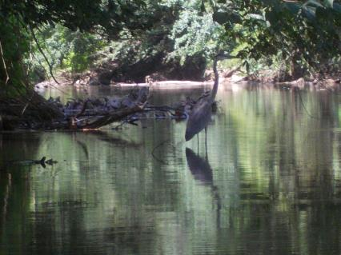
Figure 11: Great Blue Heron in the water Figure 12: Trash removed from River during paddle

