RIVANNA RIVER STEWARD REPORT
River Stewards: Justin Altice Date: 09-25-16
Starting Location and Time: Ragged Mountain Reservoir (9:30 AM)
Ending Location and Time: Ragged Mountain Reservoir (11:30 AM)
Weather: Overcast Sky Recent Precipitation: Misty rain that morning
USGS Gauges: Earlysville 0.94 ft (4 ft² / sec), Palmyra 2.4 ft (70 ft² / sec),
Water Color: Bluish/green Water Odor: None Air Temp. : 63 deg F
DO: 5 ppm PH: 8 Turbidity: 20 JTU Water Temp. : 32 deg C
Water Testing Location: Just Below Parking Area @ East Side of Reservoir
---------------------------------------------------------------------------------
Land Use:
Park land around reservoir with a wooded buffer. Trail traverses the area around the Reservoir.

Wildlife Sightings and Plant Life:
Ducks, and Small Birds. Mountain Laurels adjacent to shoreline. A thick, hair like undergrowth was observed along much of the shoreline.

People Interactions:
Several people seen utilizing the trails around the reservoir, 2 fishermen along the shore, and 4 young adults swimming (which is not allowed).

Litter and Pollution:
Trash was removed from the parking area.

Overall Summary:
It was a foggy, misty, and overcast morning. The water temperature was high in relation to the air temperature which caused for an interesting fog to roll on top of the water. It was a nice morning for a peaceful paddle enjoying the natural scenery around the Reservoir. The paddle was done to identify the viability and timing of this paddle for a low water alternative to RCAs Fall Sojourn on Oct 16th.

Actions Needed – level of priority (1 highest/5 lowest):
2 – Identify the thick undergrowth along the shoreline.
1 – Report swimmers in Reservoir.

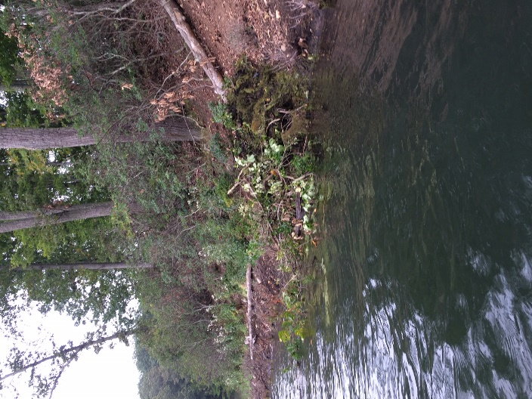
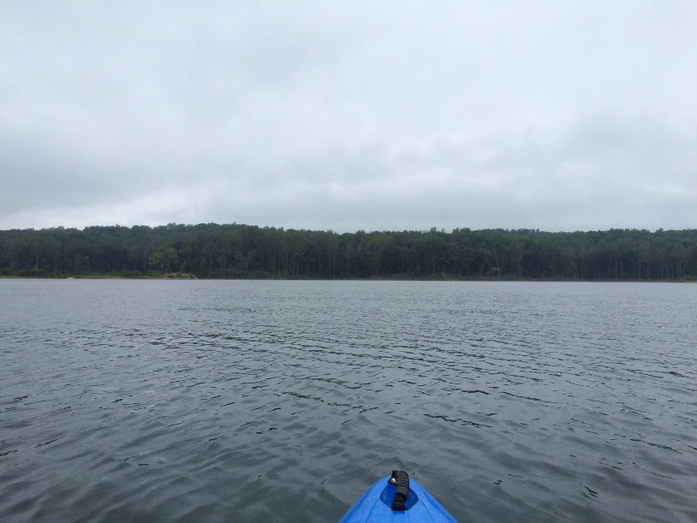
Figure 1: View from Reservoir.

Figure 2: Animal habitat along shoreline

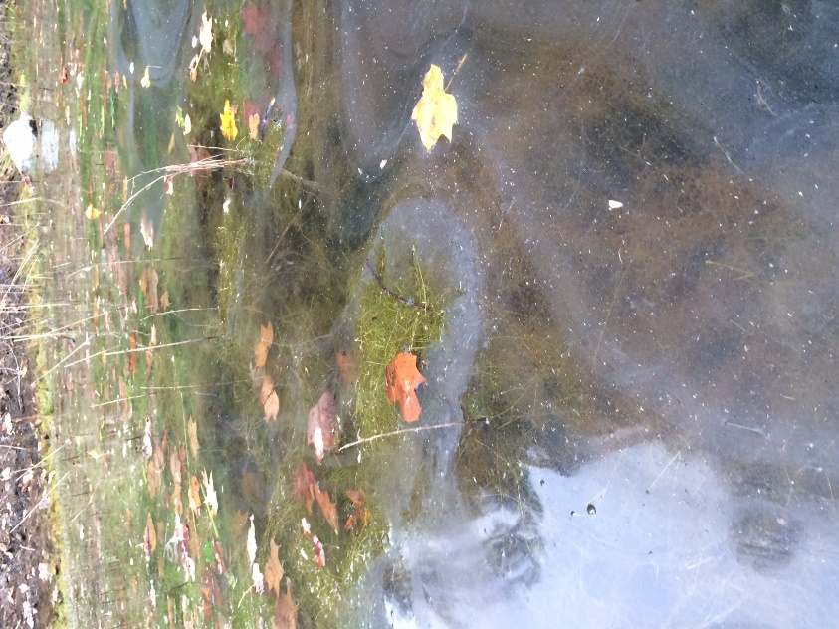
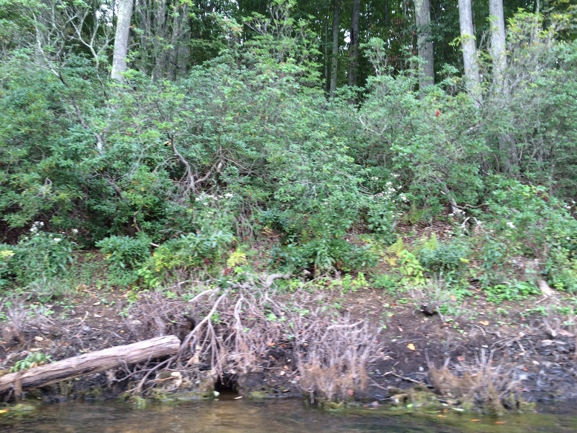
Figure 3: Patch of Mt Laurel along shoreline.

Figure 4: Shoreline along Reservoir.

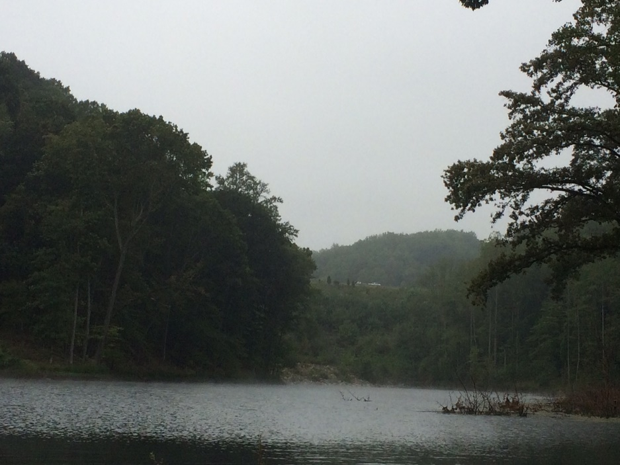
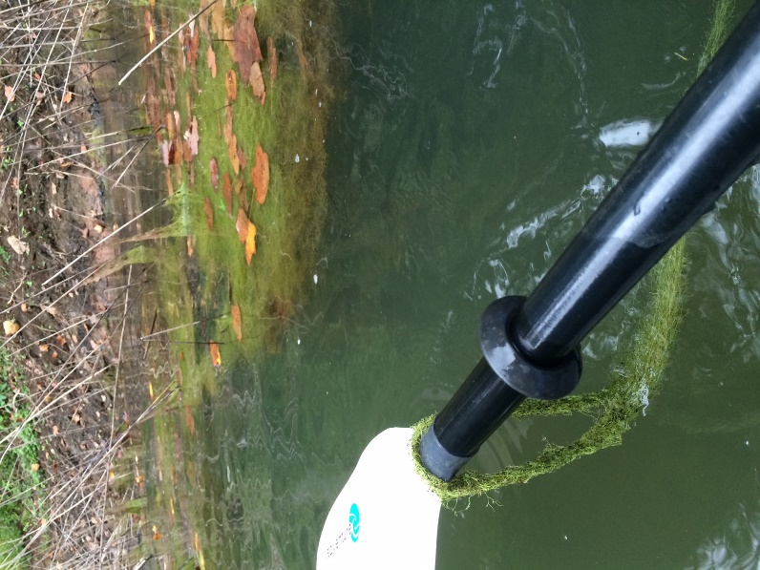
Figure 5: Thick, hair like growth along shoreline Figure 6: I-64 in the distance, on edge of Reservoir.

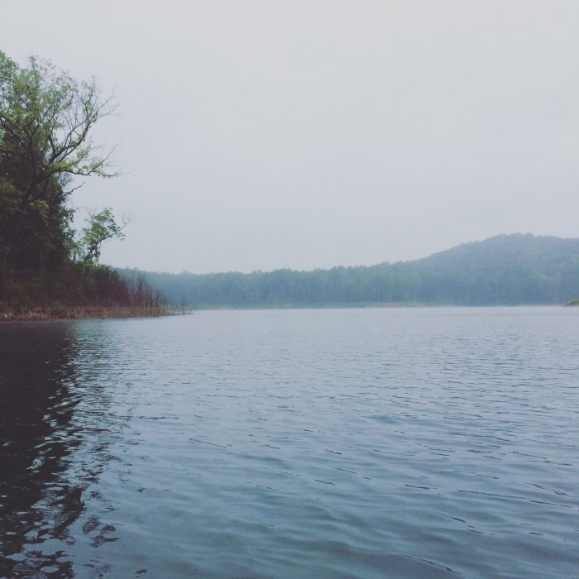
Figure 7: Foggy view of Reservoir.

