RIVANNA RIVER STEWARD REPORT
River Steward Names: Dan Triman and Justin Altice Date: 10-01-15
Other Paddlers: Nick DiPasquale, Director of EPA’s Chesapeake Bay Program, Dave Smith, RCS Board Member, Bill Emory, and Robbi Savage, RCS Executive Director
Starting Location and Time: Darden Towe Park (1:30 PM)
Ending Location and Time: Riverview Park (2:30 PM)
Weather: Cloudy and Rainy Recent Precipitation: Heavy rain the day before
Water Flow: Very Fast Water Color: Orangish Brown Water Odor: Slight
Water Temp. : 20 deg C Air Temp. : 60 deg F
DO: 6 ppm PH: 7 Turbidity: 60 JTU
USGS Water Gauge Readings: Earlysville 3.0 ft. Palmyra 5.0 ft
Physical Location Characteristics: Riverview Park
Location Tested: At boat ramp put in River Right
---------------------------------------------------------------------------------
Land Use:
Residential mainly, with some commercial use

Wildlife Sightings and Plant Life:
Ducks and Smaller Birds; Patch of bamboo river right just after Darden Towe put in.

People Interactions:
Due to the weather conditions and high water levels, we didn’t see anyone else out on the river. We talked to a couple of people at Riverview Park.

Litter and Pollution:
There wasn’t a whole lot of trash along this stretch of the River. We picked up a couple of cans and bottles, and found one large Styrofoam object with a light attached to it.

Overall Summary:
The heavy rain storm yesterday, and light rain today caused for very high water levels and muddy conditions. The water was full of sediment so was a very orange color. Water levels were high enough that we pretty much floated over all of the usually exposed rocks, and the current was moving much faster than usual. This paddle included a group of 6 of us, including Robbi Savage and Dave Smith (RCS), Bill Emory, and Nicholas DiPasquale (EPA Director of the Chesapeake Bay Program Office).

Actions Needed – level of priority (1 highest/5 lowest):
None

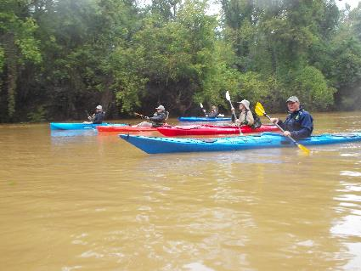
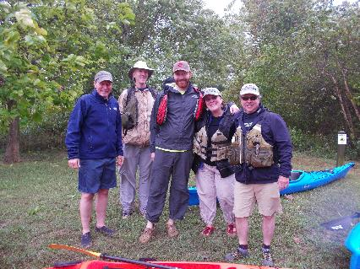
Figure 1: The group gathered together before the float Figure 2: Everyone having a good time on the river.
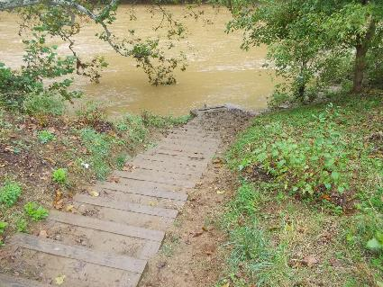
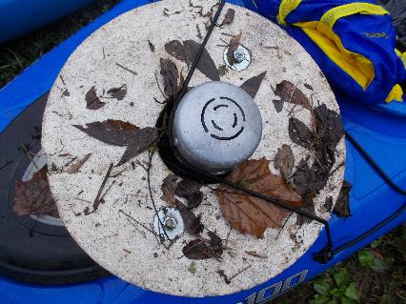
Figure 3: The Styrofoam light we found in the river. Figure 4: The steps at the boat put in at Riverview Park

