RIVANNA RIVER STEWARD REPORT
River Steward Names: Dan Triman & Justin Altice Date: 10-05-14
Starting Location and Time: Rivanna Reservoir-Earlysville Rd (2:00 PM)
Ending Location and Time: Rivanna Reservoir-Rio Mills Rd (4:00 PM)
Weather: Sunny / Windy Recent Precipitation: One rain event this week
Water Flow: Slow Water Color: Blue Water Odor: None
Water Temp. : 20 deg C Air Temp. : 62 deg F
DO: 4 ppm PH: 6 Turbidity: 30 JTU
USGS Water Gauge Reading: Earlysville 1.14 ft.
Physical Location Characteristics: Just before Rio Mills Dam
Location Tested: Middle of Reservoir
---------------------------------------------------------------------------------
Land Use:
Mostly residential, with some commercial and the water treatment plant. Generally wooded areas around the Reservoir.

Wildlife Sightings and Plant Life:
Ducks, small birds, turtles, fish, 1 osprey, and 2 blue herons

People Interactions:
There were a lot of people out using the Reservoir this afternoon. Overall we saw about 10 kayakers, several people fishing, and several people rowing in boats.

Litter and Pollution:
We didn’t really find any trash during our paddle. A couple of cans at the boat put in at Earlysville Rd was all we found.

Overall Summary:
Since the water levels in the Rivanna River have been so low lately, we decided to paddle the Reservoir and see how things looked there. Overall things looked pretty good, with no major issues found. We saw a lot more people on the water than during our typical River paddles. We did see a good amount of wildlife as well on our trip. Paddling was much easier on the Reservoir than it would have been on the River due to current water levels.

Actions Needed – level of priority (1 highest/5 lowest):
None
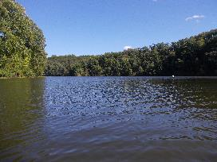
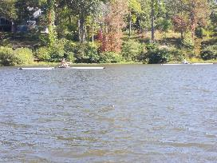
Figure 1: Some of the rowers we saw on the Reservoir Figure 2: View of the Reservoir looking down river.

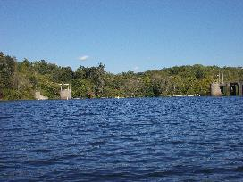
Figure 3: View of the Rio Mills Dam

