RIVANNA RIVER STEWARD REPORT
River Steward Names: Dan Triman Date: 10-14-15
Starting Location and Time: Beaver Creek Reservoir (9:45 AM)
Ending Location and Time: Beaver Creek Reservoir (11:45 AM)
Weather: Cloudy w/ some sun Recent Precipitation: Fairly dry the past week
Water Flow: None Water Color: Clear Water Odor: None
Water Temp. : 18 deg C Air Temp. : 65 deg F
DO: 6 ppm PH: 8 Turbidity: 10 JTU
USGS Water Gauge Readings: Earlysville 1.58 ft, Palmyra 3.04 ft
Physical Location Characteristics: Southeast side of the reservoir
Location Tested: At boat ramp put in
---------------------------------------------------------------------------------
Land Use:
Park land, with some residential and farm land as well.

Wildlife Sightings and Plant Life:
1 Heron, Lots of Geese and Ducks and Smaller Birds, Turtles, 2 young deer on the river bank, Black Swans, and evidence of Beavers (chewed tree trunks); Lots of vegetation around and in the reservoir, fall colors starting to show on trees, several downed trees along the banks.

People Interactions:
I saw 1 person in a fishing boat, and 2 people canoeing on the reservoir.

Litter and Pollution:
Only a couple of small pieces of trash found such as cans and bottles and fishing bait boxes. Also found one small tire buried in the water in the northern most section of the reservoir.

Overall Summary:
It was a beautiful day to paddle out a Beaver Creek. Saw a lot of wildlife and vegetation, as well as a couple of people boating on the water. Very scenic with fall colors on tree leaves, and water looked pretty clear and clean for the most part. We will hold our annual Fall Sojourn at Beaver Creek later this week on October 18th.

Actions Needed – level of priority (1 highest/5 lowest):
3 – Remove buried tire in northen most part of the reservoir.

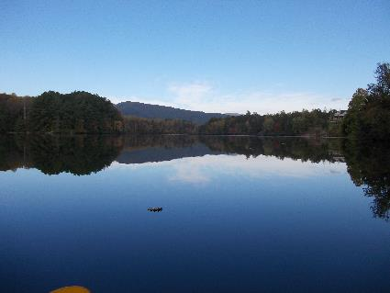
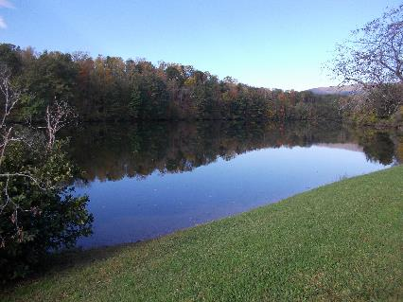
Figure 1: View of the Reservoir looking Northwest Figure 2: View from the middle of the reserovir
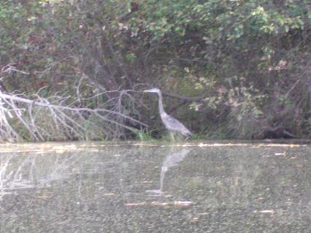
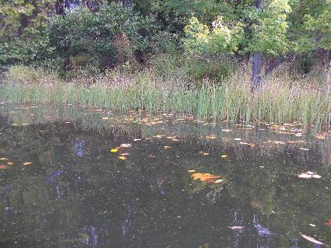

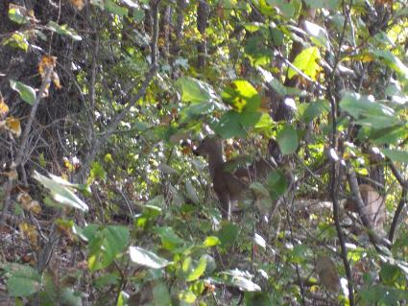
Figure 3: Example of grasses growing in water at edge Figure 4: Heron on the edge of the water.
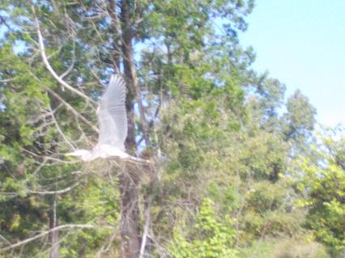
Figure 5: Heron in full flight Figure 6: Young deer in on the bank

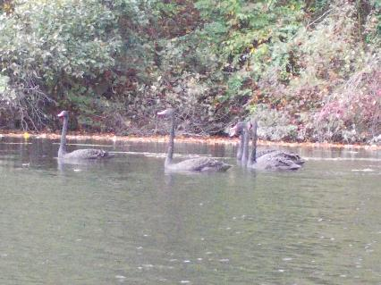
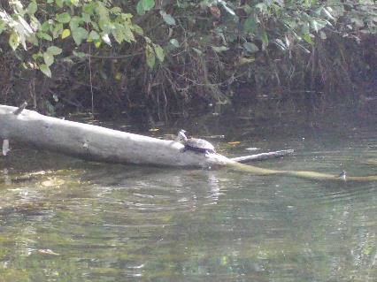
Figure 7: Turtle sunning on a log Figure 8: Black swans swimming in the water
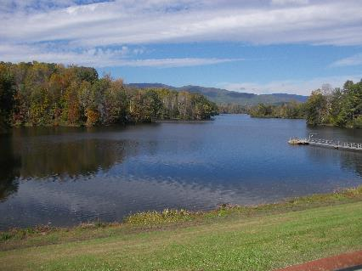
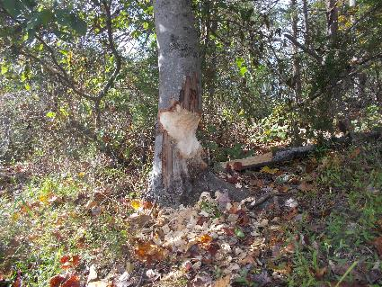

Figure 9: Evidence of beavers – chewed tree trunk Figure 10: View from the road below the reservoir
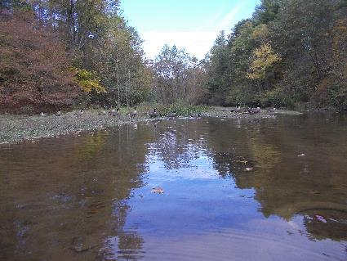
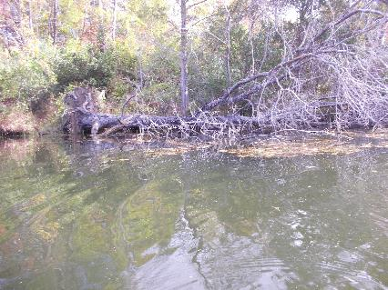
Figure 11: One of the downed trees in the water Figure 12: Lots of geese in the northern most part of the water

