RIVANNA RIVER STEWARD REPORT
River Steward Names: Dan Triman and Justin Altice Date: 10-18-15
Starting Location and Time: Beaver Creek Reservoir (10:15 AM)
Ending Location and Time: Beaver Creek Reservoir (12:15 PM)
Weather: Sunny and Windy Recent Precipitation: Fairly dry the past week
Water Flow: None Water Color: Clear Water Odor: None
Water Temp. : 18 deg C Air Temp. : 40-50 deg F
DO: 5 ppm PH: 7 Turbidity: 5 JTU
USGS Water Gauge Readings: Earlysville 1.54 ft, Palmyra 2.92 ft
Physical Location Characteristics: Southeast side of the reservoir
Location Tested: At boat ramp put in
---------------------------------------------------------------------------------
Land Use:
Park land, with some residential and farm land as well.

Wildlife Sightings and Plant Life:
Geese, Turtles, 5 Black Swans, Tree Swallows, Crows, and evidence of Beavers (chewed tree trunks); Lots of underwater vegetation in the reservoir, fall colors showing on trees, several downed trees along banks.

People Interactions:
Other than our group of paddlers, we saw another couple of people out on the reservoir canoeing. There was also a fishing class going on at the park.

Litter and Pollution:
Only a couple small pieces of trash found such as bottles, a lid to a pot, a soccer ball, and some plastic bags. We removed 1 tire from the reservoir, but noticed 2 others we will come back in the Spring and get when the water is warmer.

Overall Summary:
We had 13 people come on our Fall Sojourn paddle. We partnered with Blue Ridge Mountain Sports, and Rivanna River Company. It was a cold morning, but the sun came out and everyone had a good time. Saw several birds and good fall colors on the trees. Water looked clean and clear. Dan Mahon met us on the water in his sailboat to serve us hot apple cider, and also gave a short talk about park management and local history.

Actions Needed – level of priority (1 highest/5 lowest):
3 – Remove 2 more buried tires in northern most part of the reservoir.

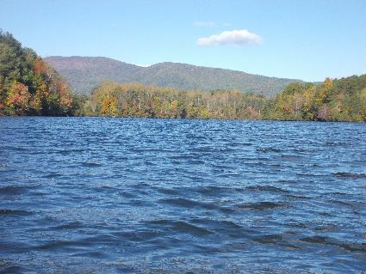
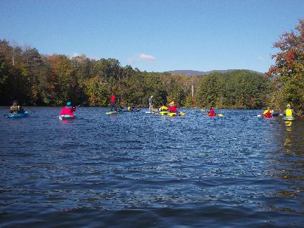
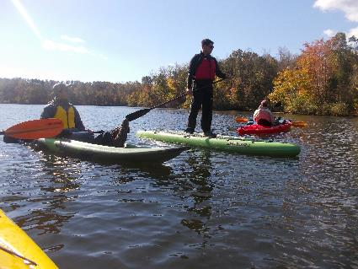
Figure 1: The sojourn group getting started in the morning Figure 2: View looking north on the reserovir
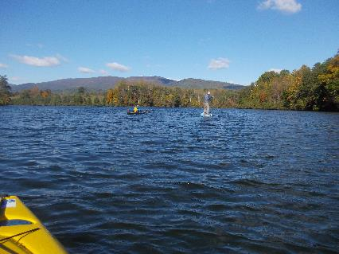

Figure 3: Kayakers and stand up paddle boarders Figure 4: Gabe and Aaron leading the way
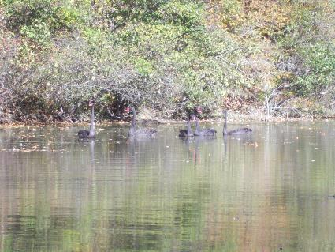
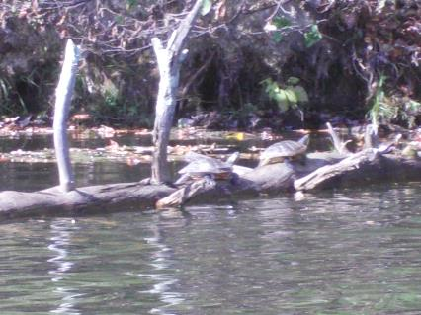
Figure 5: 2 turtles on a log Figure 6: 5 Black swans swimming in the water

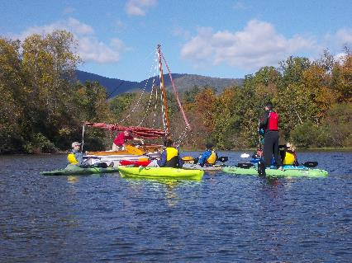
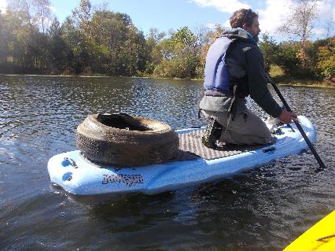
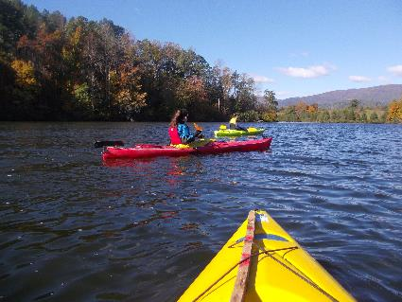
Figure 7: The tire we removed from the reservoir Figure 8: Dan Mahon serving apple cider from his sailboat
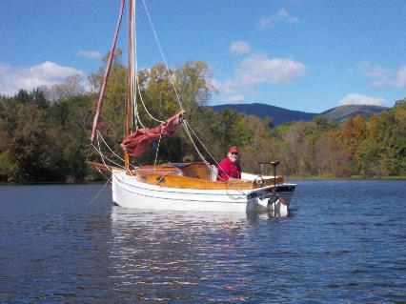

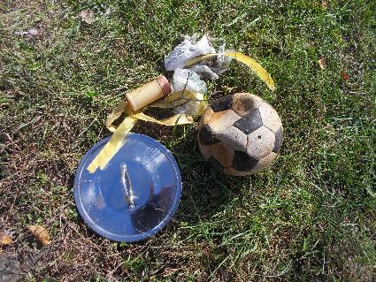
Figure 9: 2 Students from Western Albemarle High School Figure 10: Captain Dan
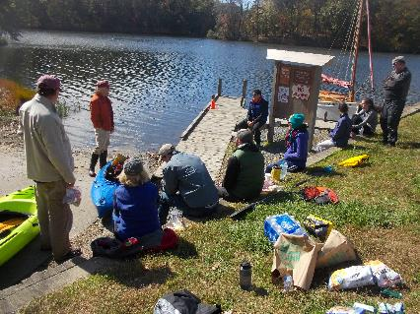

Figure 11: Some of the trash removed from the reservoir Figure 12: The group enjoying lunch and Dan Mahon’s talk

