RIVANNA RIVER STEWARD REPORT
River Steward Name(s): Dan Triman and Justin Altice Date: 10-21-15
Starting Location and Time: Rio Mills 2:30 PM
Ending Location and Time: Darden Towe 5:30 PM
Weather: Sunny with a few clouds Recent Precipitation: Mostly dry recently
Water Flow: Moderate Water Color: Mostly Clear Water Odor: None
Water Temp. : 16 deg C Air Temp. : 70 deg F
DO: 6 ppm PH: 8 Turbidity: 5 JTU
USGS Water Gauge Reading: Earlysville 1.52 ft, Palmyra 2.88 ft
Physical Location Characteristics: North Fork of Rivanna River
Location Tested: Just above Confluence of North Fork and South Fork at river left.
---------------------------------------------------------------------------------------------
Land Use:
Starts as commercial at beginning of trip, transitioning to open or wooded space, with some residential mixed in along the way.

Wildlife Sightings and Plant Life:
Ducks, geese, crows, 1 bald eagle, 1 blue heron, 1 hawk, turtles, 1 beaver, squirrels on the banks, small fish; heard frogs as well. Nice fall colors on trees, invasive plants like bamboo noticed, good amount of fallen trees.

People Interactions:
We saw a total of 3 people total, 2 were fishing near Rio Mills, and the other was walking with their dog at Darden Towe Park.

Litter and Pollution:
There wasn’t much litter found during the paddle, just a couple of smaller pieces of trash. We saw 3 tires during the paddle (2 in the water, and 1 on the bank). There is still a large piece of a car in a tree near Darden Towe.

Overall Summary:
Overall river looked clean and clear, not much trash. Big tree that was blocking river near the confluence of the North and South Forks washed down river and turned and is no longer blocking the river. Some severe erosion noticed just above confluence as well. Good wildlife sightings, mostly birds today. Lots of sediment deposited on Darden boat ramp.

Actions Needed – level of priority (1 highest/5 lowest):
4 – Remove tire and piece of a car.
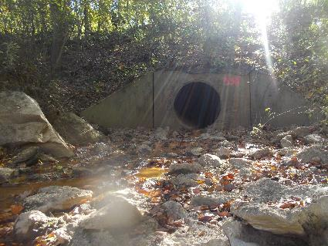
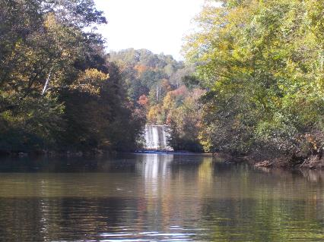
Figure 1: View of Reservoir Dam from below Figure 2: Pipe just below 29 bridge near Rio Mills
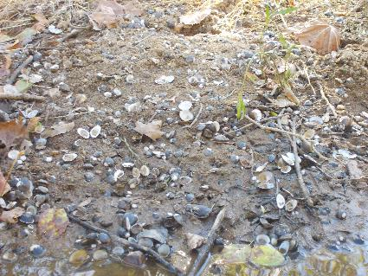
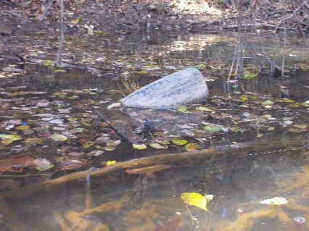
Figure 3: One of the tires found in the river Figure 4: Lots of small shells were noticed on the banks

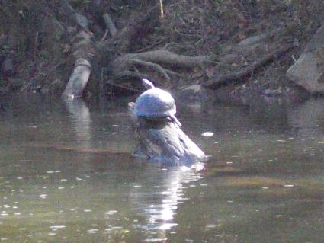
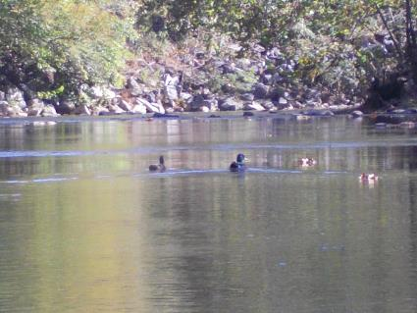

Figure 5: 2 Ducks floating down the river Figure 6: Large turtle on a log

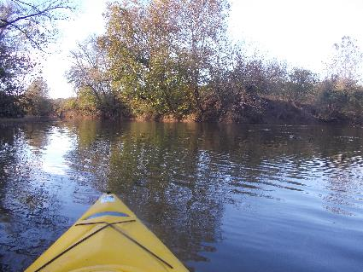
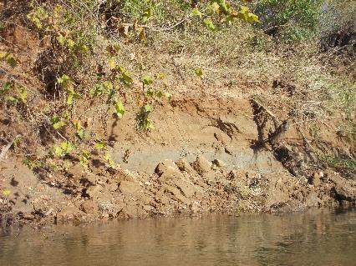
Figure 7: Example of erosion along the banks Figure 8: View of the confluence of South and North Forks
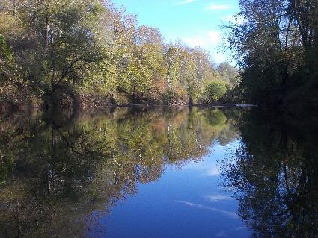
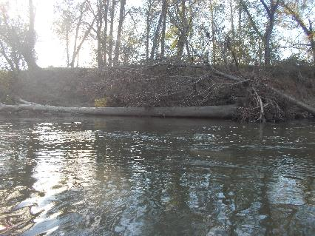
Figure 9: The tree that is no longer blocking the river Figure 10: Nice shot of fall colors and reflection on the water

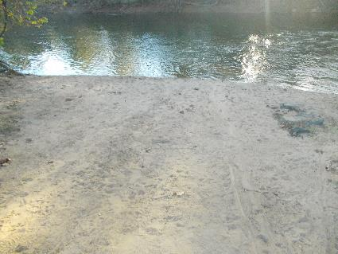
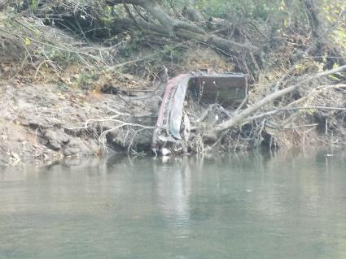

Figure 11: Piece of a car near Darden Towe Figure 12: Sediment from heavy rains at Darden boat ramp

