RIVANNA RIVER STEWARD REPORT
River Steward Names: Dan Triman & Justin Altice Date: 10-24-14
Starting Location and Time: Reas Ford Rd (3:00 PM)
Ending Location and Time: Earlysville Rd (5:30 PM)
Weather: Sunny Recent Precipitation: Not much rain recently
Water Flow: Slow Water Color: Blue Water Odor: None
Water Temp. : 16 deg C Air Temp. : 70 deg F
DO: 4 ppm PH: 8 Turbidity: 50 JTU
USGS Water Gauge Reading: Earlysville 1.30 ft.
Physical Location Characteristics: Small Island at River Left
Location Tested: Across from end of Green Meadows Lane
---------------------------------------------------------------------------------
Land Use:
Mostly farmland and wooded areas with some residential areas closer to the Reservoir.

Wildlife Sightings and Plant Life:
Ducks, small birds, geese, turtles, fish, 1 osprey, and 6 herons. Fall colors on trees. More wetland type grasses & plants than other sections of River.

People Interactions:
We saw the UVA Rowing Team out practicing, several other individuals rowing, and a couple of people kayaking today.

Litter and Pollution:
We found a few pieces of scattered trash during the paddle (such as bait boxes, cans, and bottles), but overall there wasn’t a whole lot of trash.

Overall Summary:
This was the first time we had paddled this section of the South Fork and we were really impressed with how wide open and scenic this paddle was. The water levels were good for a smooth paddle. Some of the trees had their fall colors which added to the scenery. We saw a lot of birds and other wildlife. This section was pretty clean as far as trash, but there were some areas with heavy sedimentation deposited over the years.

Actions Needed – level of priority (1 highest/5 lowest):
None
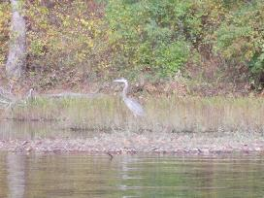
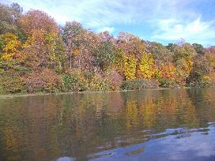
Figure 1: View of leaves with fall colors along River Figure 2: Heron standing on side of River

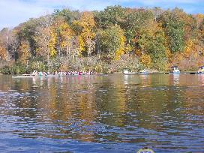
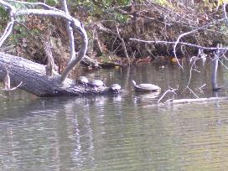
Figure 3: Turtles sunning on a log Figure 4: UVA Women’s Rowing Team practicing

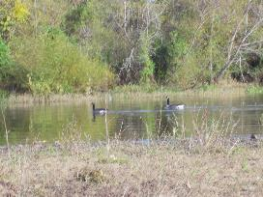
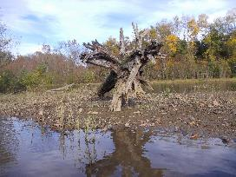

Figure 5: Small Island where water test was conducted Figure 6: Geese swimming in the River

