RIVANNA RIVER STEWARD REPORT
River Stewards: Dan Triman and Justin Altice Date: 10-26-16
Starting Location and Time: Darden Towe (4:15 PM)
Ending Location and Time: Riverview Park (6:00 PM)
Weather: Sunny with some clouds Recent Precipitation: None
USGS Gauges: Earlysville 1.21 ft (18 ft³ / sec), Palmyra 2.50 ft (92 ft³ / sec),
Water Color: Clear Water Odor: None Air Temp. : 60 deg F
DO: 5 ppm PH: 7 Turbidity: 0 JTU Water Temp. : 14 deg C
Water Testing Location: Riverview Park below the new steps at River Right
---------------------------------------------------------------------------------
Land Use:
Residential mainly, with some commercial use and park property

Wildlife Sightings and Plant Life:
Turtles, Fish, Geese, Ducks, Crows, smaller birds, and 2 Great Blue Heron. Some trees are starting to show some fall colors, while others have lost their leaves already. Lower water levels exposed a lot more underwater vegetation than we have seen recently. A couple of downed trees spotted.

People Interactions:
We didn’t see anyone else on the River today, but there were a good number of people at both Riverview and Darden, as well as jogging and biking along the county and city trails next to the River.

Litter and Pollution:
We removed about 2 bags of trash from the Rivanna today. The trash was mostly bottles and cans from drinks. We also removed a few tennis balls and other miscellaneous pieces of trash.

Overall Summary:
Water levels are extremely low right now, but water was really clear. Water temperature is getting pretty cold and not as much wildlife was seen. The new boat access steps at Riverview are complete and are already well used by the public. This was our last paddle for 2016, so we will start up our paddles again in the Spring of 2017.

Actions Needed – level of priority (1 highest/5 lowest):
3 – Monitor the old Riverview Park boat access stairs to make sure they aren’t eroding away even more and causing safety concerns.

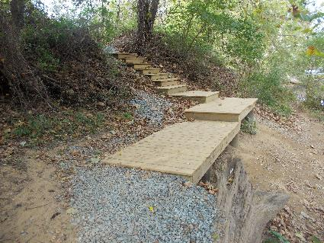
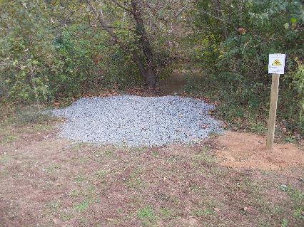
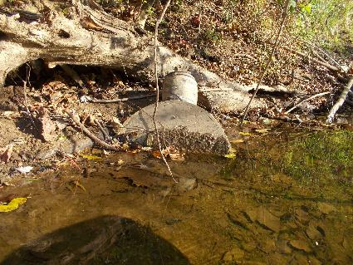
Figure 1: New Riverview Park river access and safety sign Figure 2: Completed Riverview Park access project
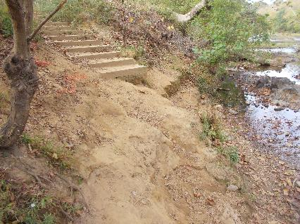
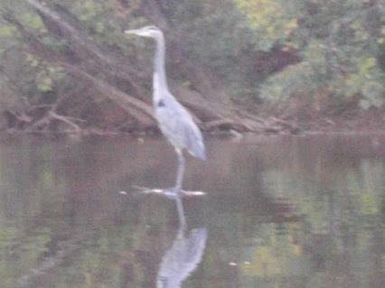
Figure 3: Old Riverview Park stairs to keep an eye on Figure 4: Manhole buried River left just past Darden Towe

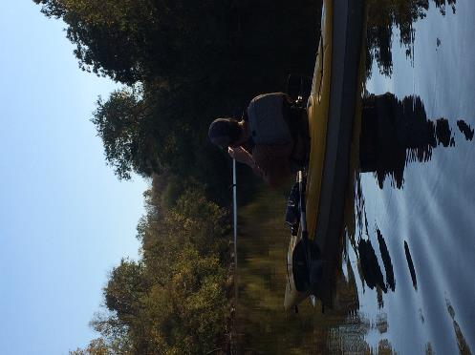

Figure 6: Close up of the Blue Heron standing in the River

Figure 5: Dan taking a photo of the Blue Heron
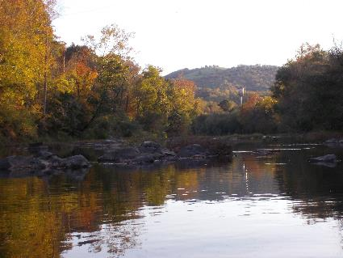
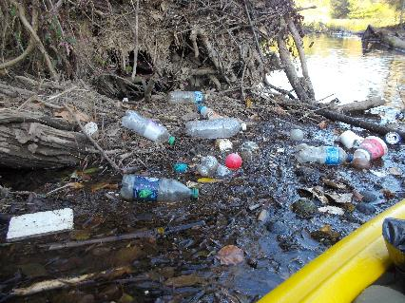
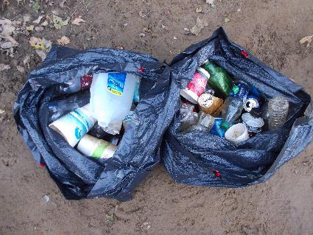
Figure 7: Worst trash area found during the paddle Figure 8: View of Fall colors looking towards Woolen Mills
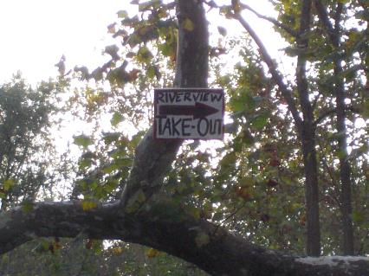
Figure 9: Riverview Park take out sign hung in downed tree Figure 10: Trash removed from the River today
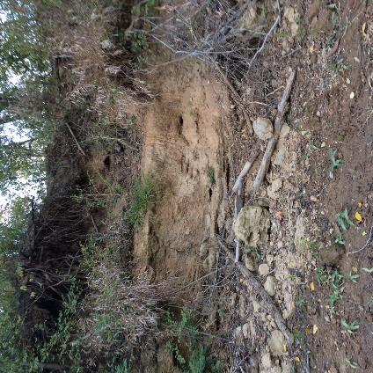
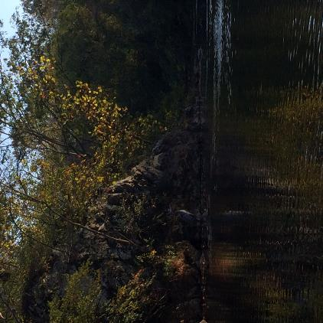
Figure 11: Second Blue Heron sighting Figure 12: Erosion on the bank

