RIVANNA RIVER STEWARD REPORT
River Steward Names: Justin Altice and Dan Triman Date: 11-04-14
Starting Location and Time: Riverview Park (2:15 PM)
Ending Location and Time: Milton (4:45 PM)
Weather: Cloudy Recent Precipitation: Very little rain lately
Water Flow: Very Slow Water Color: Mostly Clear Water Odor: None
Water Temp. : 14 deg C Air Temp. : 66 deg F
DO: 4 ppm PH: 8 Turbidity: 10 JTU
USGS Water Gauge Reading: Earlysville 1.27 ft., and Palmyra 2.60 ft.
Physical Location Characteristics: Just before Milton bridge
Location Tested: River right near bank
---------------------------------------------------------------------------------
Land Use:
Residential development with a wooded buffer around the river that contains the RTF then turning to more rural land uses towards Milton

Wildlife Sightings and Plant Life:
1 hawk, 1 kingfisher, crows, geese, ducks, several smaller birds, turtles, 1 deer, 1 beaver, 1 otter, and wild turkeys along the bank. We also saw 2 adult bald eagles and 1 younger bald eagle as well as a nest located on a power line tower at approx. 38°00'31.7"N 78°25'26.0"W. A lot more of the leaves had fallen off the trees along the river.

People Interactions:
We talked to 1 man at Riverview Park before we started our paddle. He had just moved to town and had some questions about paddling the Rivanna.

Litter and Pollution:
We removed some plastic and glass bottles, a 4x4 wood post, and found a canoe paddle along the river bank. There were many plastic bags in trees, and litter accumulated in debris piles. We also saw 12 tires, a shopping cart near Woolen Mills, and a newspaper box and payphone near Milton bridge.

Overall Summary:
Water levels were extremely low. Lots of wildlife seen, not many people seen. Some trash and large objects encountered during the paddle.

Actions Needed – level of priority (1 highest/5 lowest):
4 – Remove more tires, remaining small trash, and larger trash items from River; 4 – Repair vandalized Milton kiosk
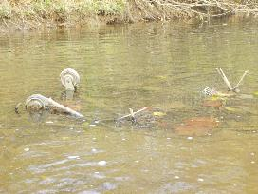
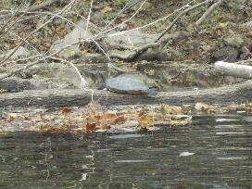
Figure 1: Turtle relaxing on a log Figure 2: Buried shopping cart near Woolen Mills
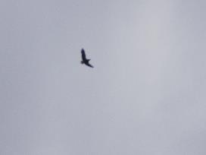
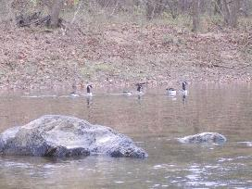
Figure 3: Geese swimming in the river Figure 4: Younger bald eagle in flight
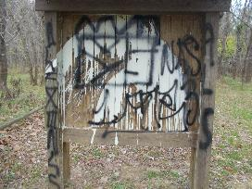
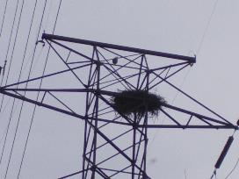

Figure 5: Eagles nest on power line tower. Younger bald Figure 6: Milton kiosk that has been vandalized
eagle sitting on tower just above nest to the left.

