RIVANNA RIVER STEWARD REPORT
River Steward Names: Dan Triman & Justin Altice Date: 11-04-15
Starting Location and Time: Rivanna Reservoir (2:30 PM)
Ending Location and Time: Rivanna Reservoir (4:30 PM)
Weather: Sunny w/ some clouds Recent Precipitation: Fairly dry
Water Flow: Slow Water Color: Blue Water Odor: None
Water Temp. : 16 deg C Air Temp. : 65 deg F
DO: 6 ppm PH: 7 Turbidity: 20 JTU
USGS Water Gauge Reading: Earlysville 1.90 ft., Palmyra 3.36 ft.
Physical Location Characteristics: Just before Rio Mills Dam
Location Tested: Reservoir Right headed downstream
---------------------------------------------------------------------------------
Land Use:
Mostly residential, with some commercial and the water treatment plant. Generally wooded areas around the Reservoir.

Wildlife Sightings and Plant Life:
Ducks, small birds, turtles, fish, geese, and 4 blue herons

People Interactions:
We saw two people fishing at the Woodlands Rd bridge, and the UVA rowing team out on the Reservoir

Litter and Pollution:
A few smaller pieces of trash found, such as a couple of cans and bottles and fishing bait containers. There was a significant amount of trash identified just above the Dam at Reservoir Right head downstream – see photo below.

Overall Summary:
We started and ended the paddle at the public boat ramp off of Woodlands Rd, and went down to the Dam and back during the paddle. The water levels in the Reservoir were still up compared to recent weeks due to the heavy rains last week. Alex from The Lewis and Clark Center came on the paddle with us today. Overall things looked pretty good, with no major issues found other than the large amount of trash above the Dam. We did see a good amount of wildlife as well on our trip.

Actions Needed – level of priority (1 highest/5 lowest):
3 – Clean up trash near the Dam
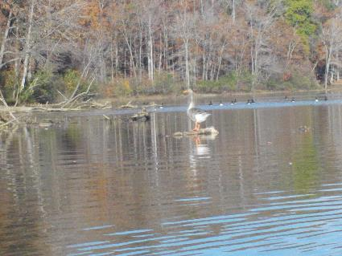
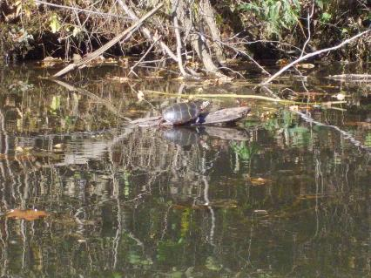
Figure 1: Turtle on a log Figure 2: Geese seen in the Reservoir
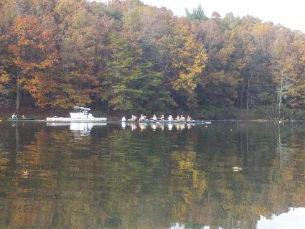
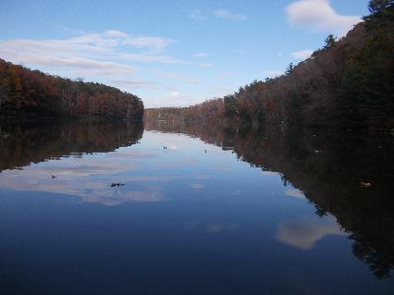
Figure 3: View of the trees and sky from the Reservoir Figure 4: UVA Rowing Team out practicing

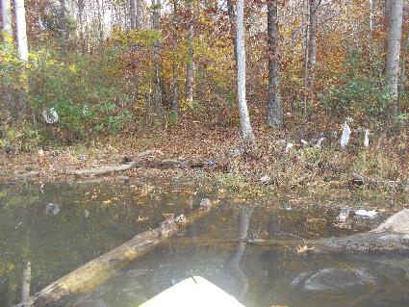
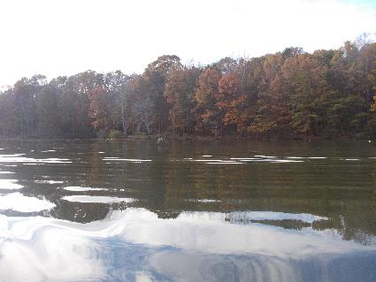

Figure 5: Heron flying above the water Figure 6: Trash found just above the Dam

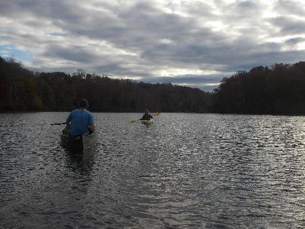
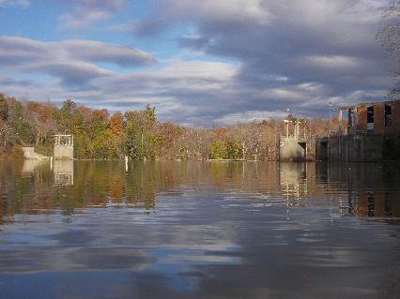
Figure 7: View of the Dam looking downstream Figure 8: Alex and Justin paddling
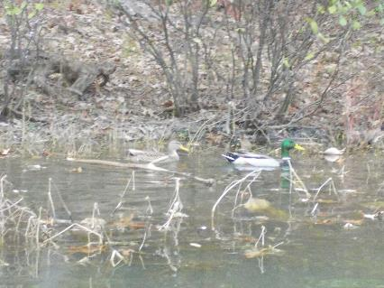
Figure 9: Ducks seen near the Earlysville Rd Bridge

