RIVANNA RIVER STEWARD REPORT
River Steward Names: Dan Triman Date: 11-07-15
Starting Location and Time: Rivanna Reservoir (1:00 PM)
Ending Location and Time: Rivanna Reservoir (4:00 PM)
Weather: Cloudy / Rainy Recent Precipitation: Rain most of the day
Water Flow: Slow Water Color: Blue Water Odor: None
Water Temp. : 16 deg C Air Temp. : 60 deg F
DO: 6 ppm PH: 7 Turbidity: 20 JTU
USGS Water Gauge Reading: Earlysville 1.75 ft., Palmyra 3.30 ft.
Physical Location Characteristics: At Earlysville Rd Bridge over Reservoir
Location Tested: Reservoir Left headed downstream
---------------------------------------------------------------------------------
Land Use:
Mostly residential, with some commercial and the water treatment plant. Generally wooded areas around the Reservoir.

Wildlife Sightings and Plant Life:
Ducks, small birds, turtles, fish, 3 blue herons, and what we think was a young bald eagle flying overhead.

People Interactions:
We saw one other group of 4 people kayaking on the Reservoir

Litter and Pollution:
In total we removed about 5 full trash bags worth of trash from the area. It was mostly cans, bottles, fishing bait boxes, buckets, rags, plastic bags, etc. The majority of the trash came from the location just above the Dam, mentioned in our last paddle report earlier this week. That area is now clean.

Overall Summary:
It rained for the first half of our paddle and then we had clear skies the rest of the time. We started and ended the paddle at the public boat ramp off of Woodlands Rd, and went down to the Dam and back. The purpose of this paddle was to take a local Western Albemarle High School student (Jessica Trice) out to do a clean up on the Rivanna as part of a project she was working on. I was accompanied on the paddle by Jessica, her mom Mary Ann, a friend Ellis Johns, and his son Mac Johns.

Actions Needed – level of priority (1 highest/5 lowest):
None
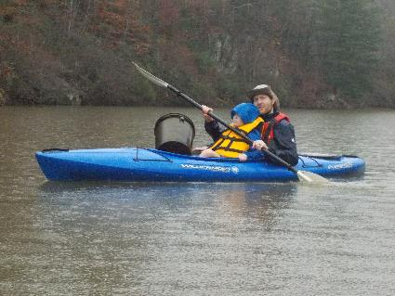
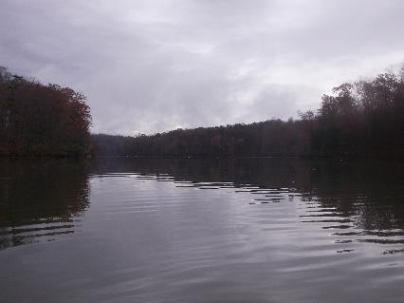
Figure 1: View of the Reservoir Figure 2: Ellis and Mac with one of the buckets we found
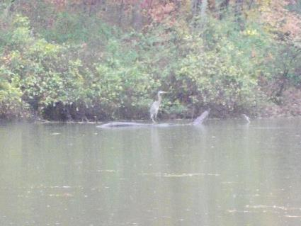
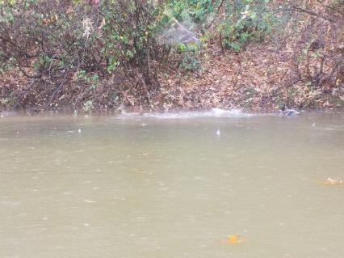
Figure 3: A couple of ducks in the water Figure 4: One of the Herons we saw

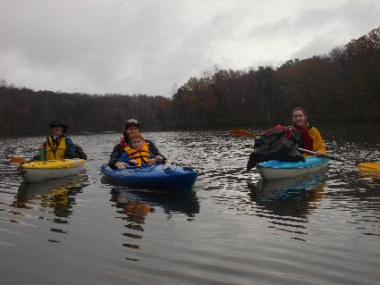
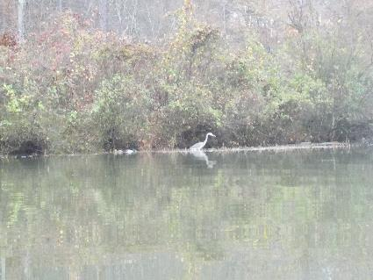

Figure 5: Another Heron and some ducks Figure 6: The group on the way back to the boat ramp

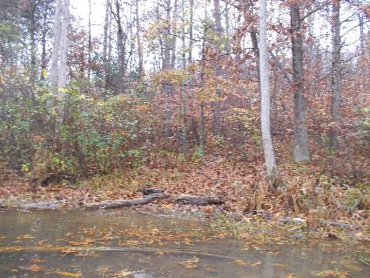
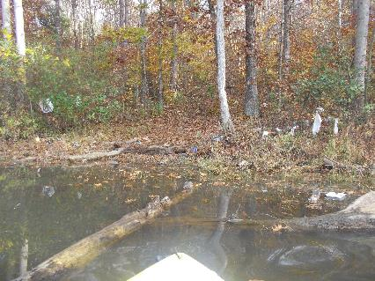
Figure 7: Photo of trash area from 11/04/15 Figure 8: Same area after we cleaned it up today
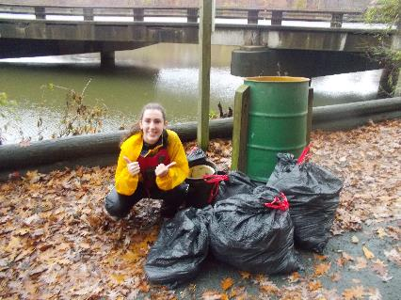
Figure 9: Jessica posing with all the trash we removed

