RIVANNA RIVER STEWARD REPORT
River Steward Name(s): Dan Triman Date: 06-07-14
Starting Location and Time: Milton 10:30 AM
Ending Location and Time: Crofton 3:00 PM
Weather: Sunny and Clear Skies Recent Precipitation: 1 rain past few days
Water Flow: Slow Water Color: Mostly clear Water Odor: None
Water Temp. : 28 deg C Air Temp. : lower to mid 80’s
DO: 3 ppm PH: 8.0 Turbidity: 10 JTU
USGS Water Gauge Reading: Palmyra 3.45 ft
Physical Location Characteristics: Beach area near Keswick Country Club
Specific Location Testing Performed: about 2 miles past Milton put in
Land Use:
Mostly rural farms and wooded land, with some residential areas in Keswick and Lake Monticello.

Wildlife Sightings and Plant Life:
Several turtles, a snake eating a small fish, several kingfishers, 1 bald eagle, many fish including 1 longnose gar.

People Interactions:
Saw about 10 people total kayaking, canoeing, or fishing

Litter and Pollution:
About 15 buried tires spotted throughout the paddle (removed the ones I could), removed 1 5 gallon plastic bucket, plastic bags, bottles, etc. There was also a piece of farm equipment on one of the river banks, as well as a table up high on the right side of the river in a tree near Crofton.

Overall Summary:
Generally the stretch of the river looked pretty good, with the exception of a lot of buried tires in the water, and some litter. One short stretch within the last mile before Crofton had high sedimentation levels. Lots of large downed trees blocking parts of the river. Severe erosion on banks near Keswick.

Actions Needed – level of priority (1 highest/5 lowest)
A lot of tires that need to be removed from the water (2), downed trees (2), erosion control (2).

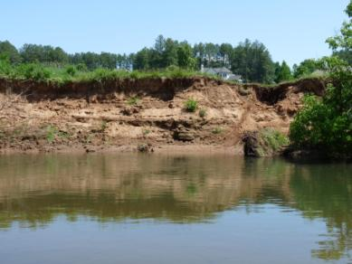
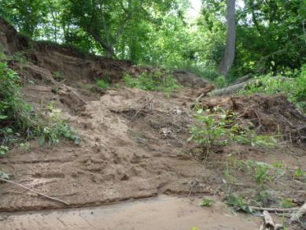
Figure 1: Example of erosion near Keswick Figure 2: Another example of erosion near Keswick

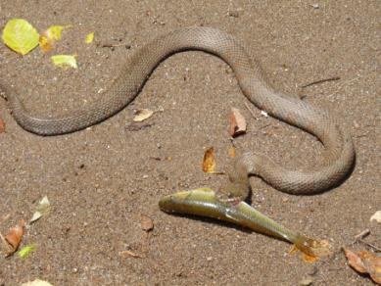
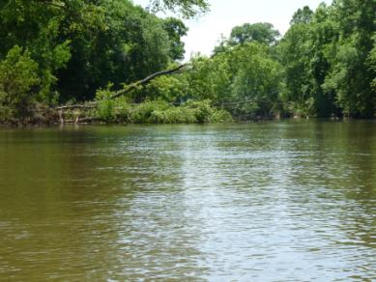
Figure 3: Example of large tree down across the river Figure 4: Snake eating a small fish

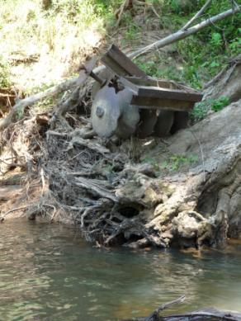
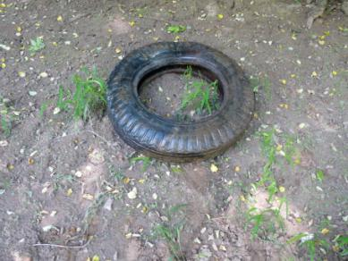

Figure 6: One of the tires removed from the river
Figure 5: Farm equipment along river bank

