RIVANNA RIVER STEWARD REPORT
River Steward Name(s): Dan Triman and Justin Altice Date: 07-02-14
Starting Location and Time: Milton 10:15 AM
Ending Location and Time: Crofton 2:15 PM
Weather: Sunny and Clear Skies Recent Precipitation: little rain recently
Water Flow: Slow Water Color: Mostly clear Water Odor: None
Water Temp. : 28 deg C Air Temp. : lower 90’s
DO: 2 ppm PH: 8.0 Turbidity: 20 JTU
USGS Water Gauge Reading: Palmyra 3.25 ft
Physical Location Characteristics: Near rocks in middle of River
Specific Location Testing Performed: about 3 miles before Crofton
Land Use:
Mostly rural farms and wooded land, with some residential areas in Keswick and Lake Monticello.

Wildlife Sightings and Plant Life:
Several turtles, 2 beavers, 2 deer, several birds (including kingfishers, 1 bald eagle, and 2 great blue herons) and many fish (including 2 longnose gar).

People Interactions:
Didn’t see any other people out during our trip

Litter and Pollution:
About 15 buried tires spotted throughout the paddle. Removed a couple pieces of trash, but not many were found. There is still a piece of farm equipment on one of the river banks (about a mile or two from Crofton), as well as a table up high on the right side of the river in a tree near Crofton.

Overall Summary:
Generally the stretch of the river looked pretty good, with the exception of a lot of buried tires in the water, and some litter. One short stretch within the last mile before Crofton had high sedimentation levels. Lots of large downed trees blocking parts of the river. Severe erosion on banks near Keswick.

Actions Needed – level of priority (1 highest/5 lowest)
A lot of tires that need to be removed from the water (2), erosion control (2).

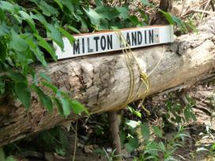
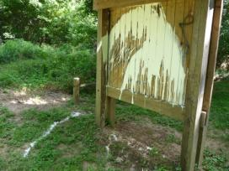
Figure 1: Milton RCS Kiosk that has paint damage Figure 2: Sign along the river at Milton that could use attention

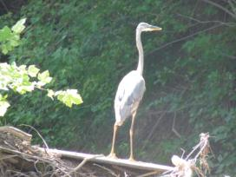
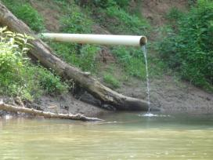
Figure 3: One of the outfall pipes along the river Figure 4: Great Blue Heron spotted along the River

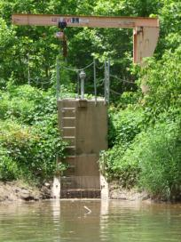
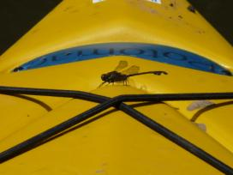

Figure 6: Dragonfly that landed on kayak
Figure 5: Lift equipment along River near Crofton

