RIVANNA RIVER STEWARD REPORT
River Steward Names: Justin Altice and Dan Triman Date: 9-3-14
Starting Location and Time: Riverview Park (4:00 PM)
Ending Location and Time: Milton (6:30 PM)
Weather: Somewhat Cloudy Recent Precipitation: Very little rain lately
Water Flow: Very Slow Water Color: Mostly Clear Water Odor: None
Water Temp. : 30 deg C Air Temp. : 87 deg F
DO: 2 ppm PH: 8 Turbidity: 30 JTU
USGS Water Gauge Reading: Earlysville 1.18 ft.
Physical Location Characteristics: Milton Boat Launch
Location Tested: River left near Milton Boat Launch
---------------------------------------------------------------------------------
Land Use:
Residential development with a wooded buffer around the river that contains the RTF then turning to more rural land uses towards Milton

Wildlife Sightings and Plant Life:
Birds (1 osprey, 1 kingfisher, several smaller birds), and several small fish

People Interactions:
Saw 1 person fishing just past Riverview, and 2 people kayaking near Milton.

Litter and Pollution:
There was a lot of litter found during the paddle. We were able to remove 2 full bags worth of glass, metal, and plastic bottles and cans, but there was still probably another 2 bags worth of trash we weren’t able to fit in our kayaks. There were also a number of larger trash items in the stretch that will need to be removed at a later date (such as about 12-15 tires, buried shopping cart, and old telephone box, etc.) Most of the tires are closer to Milton just after longest stretch of rapids at River left.

Overall Summary:
The weather was a little warmer than it has been this week, and the water levels were extremely low. Significant amounts of trash found along the River, some of which will need to be removed in the future. Not much wildlife spotted, and only a few people encountered.

Actions Needed – level of priority (1 highest/5 lowest):
4 – Remove more tires, remaining small trash, and larger trash items from River

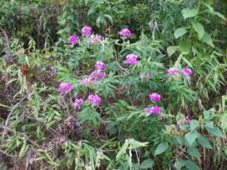
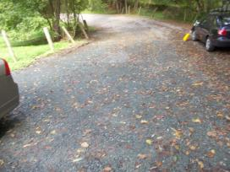
Figure 1: The gravel at Milton we laid last week Figure 2: Example of some of the flora along the River
seems to be doing really well.
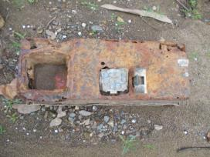
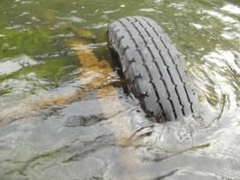
Figure 3: One of the tires in the River, this one appears Figure 4: Old telephone box found on River bank
to be a whole axle from a vehicle with tires still attached

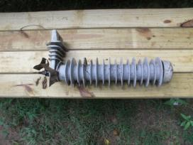
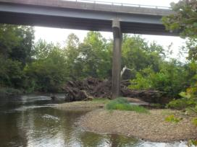

Figure 5: Large amount of debris piled at Milton bridge Figure 6: Another interesting item removed from River

